**Garage Management System –**

**Salesforce CRM Implementation Documentation**

# 1.Project overview

This Salesforce CRM project implements a comprehensive Garage Management System designed to streamline and automate key operations for automotive repair and service centers. The system aims to enhance customer service, improve operational efficiency, and provide critical business insights. It centralizes customer, appointment, service, and billing information, moving away from manual processes to a data-driven approach. Key features include automated service amount calculation, real-time service status updates, robust duplicate management, and integrated reporting for business analytics.

# 2. Objectives

The primary objective of building this Salesforce CRM is to provide a unified, efficient, and scalable platform for managing all aspects of a garage business. This system aims to achieve better customer management by maintaining detailed records and facilitating timely communication, streamline booking and service delivery processes through automation, ensure accurate billing, and empower data-driven decision-making through comprehensive reporting. Ultimately, it seeks to improve overall operational efficiency and enhance customer satisfaction, contributing directly to the business's profitability and growth.

# 3.Phase 1: Requirement Analysis & Planning

**3.1 Understanding Business Requirements:**

The project addresses several key user needs and problems:

* **Manual Processes**: Eliminating paper-based records for appointments, service tracking, and billing.
* **Inconsistent Pricing:** Automating service amount calculation to ensure uniform and accurate pricing based on selected services.
* **Lack of Real-time Status:** Providing up-to-date service status to customers and internal staff.
* **Duplicate Data:** Preventing redundant customer records to maintain data quality.
* **Limited Visibility:** Offering managers clear insights into operations, sales, and customer feedback.
* **Customer Communication:** Automating thank-you emails post-payment.
* **Data Security:** Ensuring sensitive service and customer data is accessible only to authorized personnel.

**3.2 Defining Project Scope and Objective**

The project scope includes:

* Management of Customer Details.
* Appointment scheduling and service type selection.
* Tracking of service performance and quality checks.
* Automated billing and payment confirmation.
* Comprehensive reporting and dashboarding for analytics.
* Robust user, role, and profile management for security.
* Implementation of automation (Flows, Apex) and validation rules.

**3.3 Design Data Model and Security Model:**

**Data Model:**

* **Customer Details (Custom Object):** Stores customer name, email, phone number.
* **Appointment (Custom Object):** Stores appointment date, vehicle number plate, links to Customer Details, and includes checkboxes for Maintenance, Repairs, Replacement Parts.
* **Service records (Custom Object):** Links to Appointment, tracks service status, quality check.
* **Billing details and feedback (Custom Object):** Links to Service Records, tracks payment, feedback.
* **Relationships:** All custom objects are linked via Lookup relationships forming a chain: Customer Details <- Appointment <- Service Records <- Billing details and feedback.

**Security Model:**

* **Roles:** Manager, Sales Person (hierarchy: Sales Person reports to Manager).
* **Profiles:** Manager, Sales Person (custom profiles cloned from Standard User and Salesforce Platform User respectively).
* **Organization-Wide Defaults (OWD):** Service records set to **Private**.
* **Sharing Rules:** A sharing rule (Sharing setting) ensures Service records owned by "Sales Person" users are shared with "Manager" roles (Read/Write access).
* **Public Groups:** A sales team public group created for the "Sales Person" role.

1. **Phase 2: Salesforce Development - Backend & Configurations** 
   1. **Setup Environment & DevOps Workflow:**

• The project development was conducted within a Salesforce Developer Org. Development artifacts were managed directly within the org, implying a simple change set-based or manual deployment approach for transferring components between environments if applicable.

**How to Login to Salesforce:**

1. Open Google, Search for Salesforce Login.

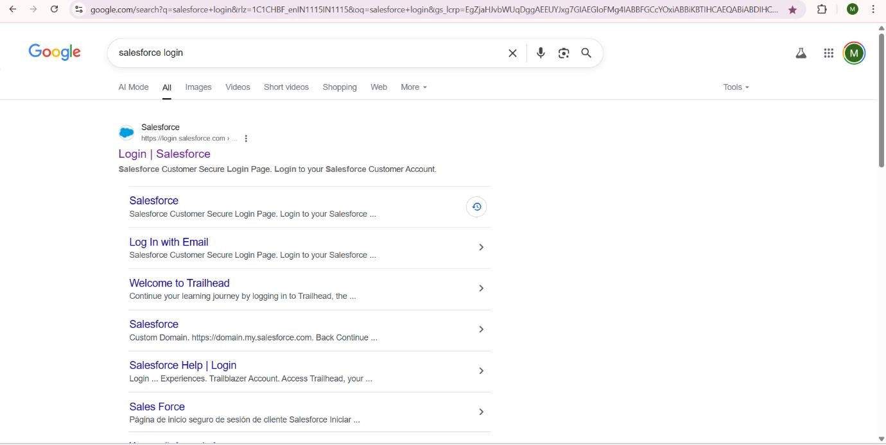

2.Click on Login button, Enter Username and password.

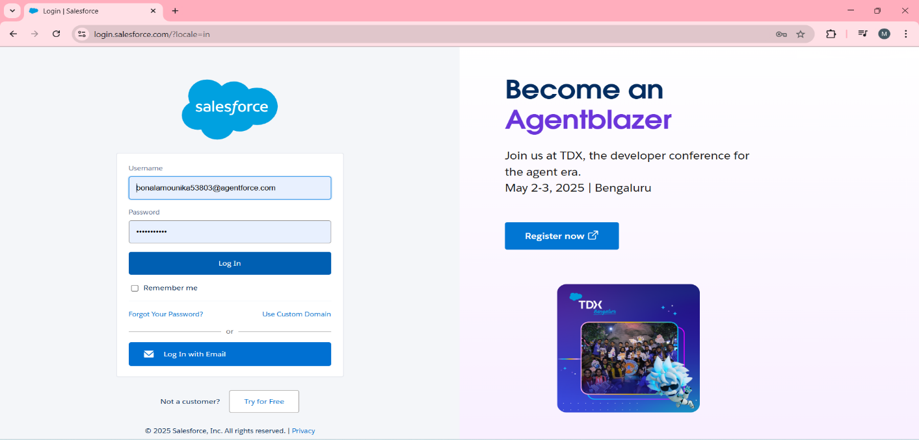

3.You will Navigate to salesforce setup page.

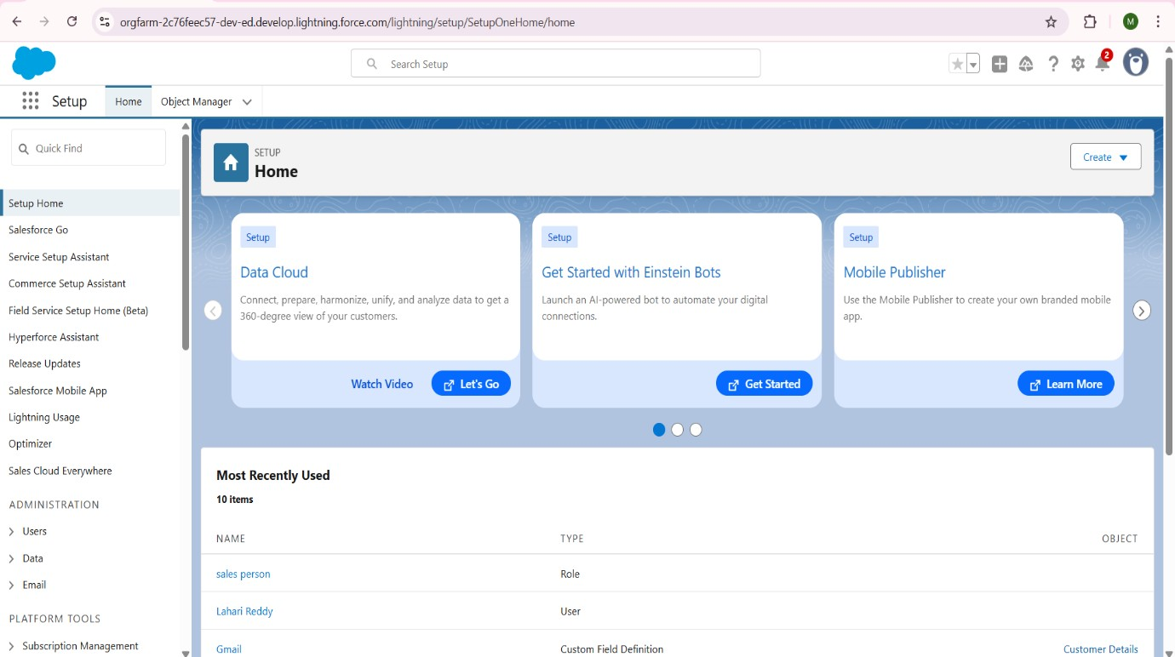

4.Click on Setup Menu,You can see a dropdown with Setup,Data cloud Setup,Service Setup,

Salesforce Go and Developer Console.

5.Click on Setup.

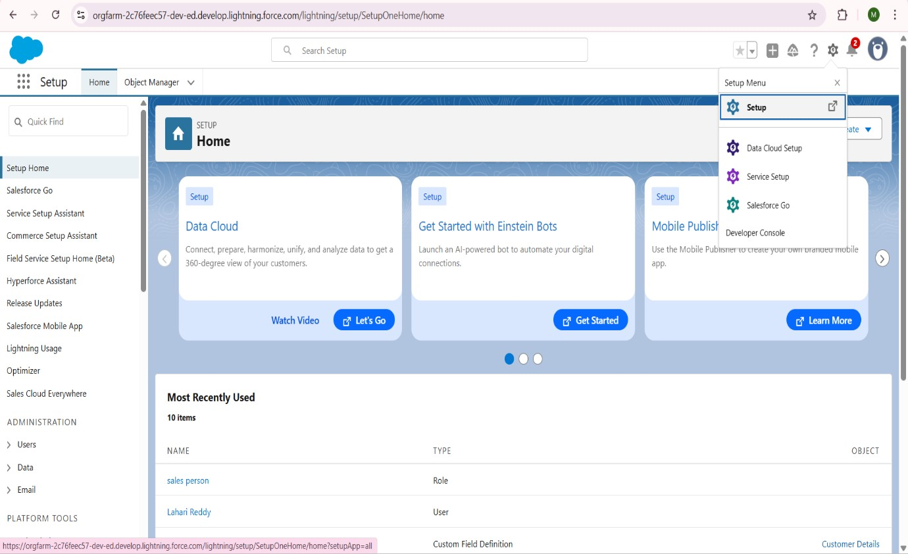

6.Then you Directly Navigated into Home Page.

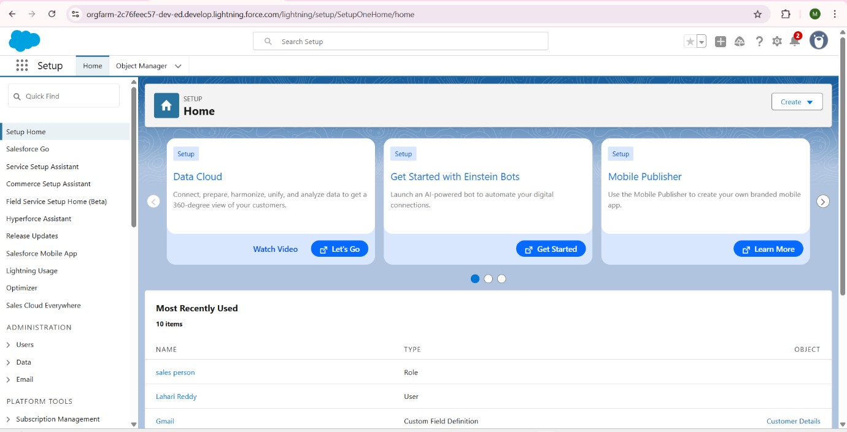

• When you click on ***Object Manager*** tab***,*** you can see Standard objects and custom objects that we use in our projects or Tasks.

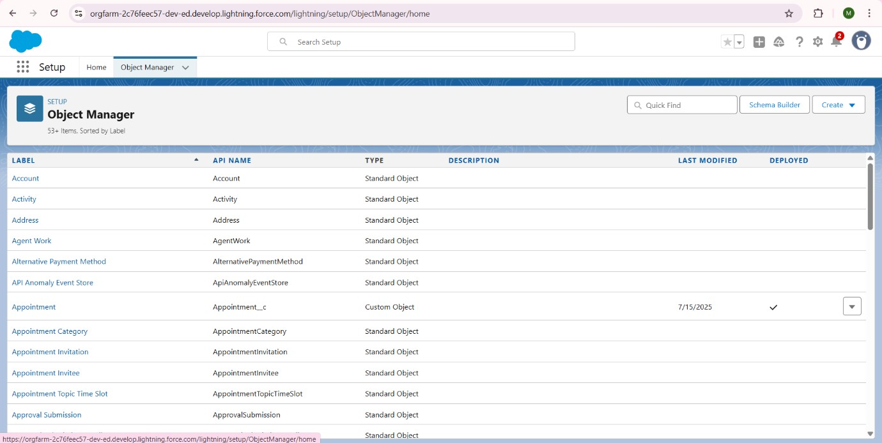

* 1. **Customization of Objects, Fields, Validation Rules, Automation:**

In Salesforce, an Object is essentially a database table that allows you to store specific types of information. Think of it like a spreadsheet or a table in a relational database. Each row in this "table" is a record, and each column is a field.

Salesforce categorizes objects into two main types:

* + - 1. **Standard Objects:** These are pre-built objects provided by Salesforce for common business needs (e.g., Accounts, Contacts, Opportunities, Leads, Cases).
      2. **Custom Objects:** These are objects that you create in Salesforce to store information that's specific to your organization's unique business needs or industry.

**Ways to Create Custom Objects in Salesforce:**

* + - 1. **Through the User Interface (Setup > Object Manager) - Most Common & Recommended for Manual Creation**: This is the primary method for declarative development. You define all the object's properties, fields, and features using a wizard.
      2. **Using Schema Builder:** A visual tool in Salesforce Setup that allows you to see, create, and modify objects and their relationships graphically. It's great for visualizing your data model. You can create new objects directly from the Schema Builder canvas.
      3. **From a Spreadsheet (via Schema Builder):** You can design your object and its fields in a CSV file and then import it directly into Schema Builder to quickly create the object and its fields.
      4. **Programmatically (using Metadata API or Tooling API):** For advanced developers or automated deployment pipelines, objects can be created and modified using code or command-line tools that interact with Salesforce's APIs.
      5. **Using Salesforce DX (CLI):** Salesforce DX is a modern development framework that allows developers to manage their Salesforce projects using command-line interface

(CLI) tools, including creating metadata components like objects from definition files.

Creating objects in Salesforce is a fundamental step in building any custom application. You define your data structure by creating these "tables" to store your specific business information.

There are several ways to create custom objects in Salesforce, ranging from declarative (point-and-click) to programmatic methods:

**Ways to Create Custom Objects in Salesforce:**

* + 1. **Through the User Interface (Setup > Object Manager) - Most Common & Recommended for Manual Creation**: This is the primary method for declarative development. You define all the object's properties, fields, and features using a wizard.
    2. **Using Schema Builder:** A visual tool in Salesforce Setup that allows you to see, create, and modify objects and their relationships graphically. It's great for visualizing your data model. You can create new objects directly from the Schema Builder canvas.
    3. **From a Spreadsheet (via Schema Builder):** You can design your object and its fields in a CSV file and then import it directly into Schema Builder to quickly create the object and its fields.
    4. **Programmatically (using Metadata API or Tooling API):** For advanced developers or automated deployment pipelines, objects can be created and modified using code or command-line tools that interact with Salesforce's APIs.

1. **Using Salesforce DX (CLI):** Salesforce DX is a modern development framework that allows developers to manage their Salesforce projects using command-line interface (CLI) tools, including creating metadata components like objects from definition files.

**How to Create an Object (Step-by-Step using the User Interface - Setup > Object Manager):**

This is the most common method you would use for your "Garage Management System" objects (like Customer Details, Appointment, etc.).

1. **Log in to Salesforce:** o Log in to your Salesforce Org (e.g., your Trailhead playground).
2. **Navigate to Setup:**
   * + Click on the **Gear icon** ( ) in the top right corner.
     + Select **Setup**.
3. **Go to Object Manager:**
   * + In the Quick Find box on the left, type Object Manager.
     + Click on **Object Manager** under Objects and Fields.
4. **Initiate New Custom Object Creation:**
   * + On the Object Manager page, click the **Create** dropdown button in the top right corner.
     + Select **Custom Object**.
5. **Fill in the Custom Object Definition Details:**

This is the core step where you define the properties of your new object.

o **Basic Information:**

* + - * + **Label:** This is the user-friendly name of your object (e.g., Customer Details). This is what users will see in the UI.
        + **Plural Label:** The plural form of your label (e.g., Customer Details).
        + **Object Name (API Name):** This is the unique programmatic name of your object. It will auto-populate based on the Label, usually with __c appended (e.g., Customer_Details__c). This is what you'll use in code, formulas, and flows.
        + **Description (Optional):** A brief explanation of what the object stores.

**Custom Objects & Fields:**

o **Customer Details:** Fields for Name, Gmail (Email), Phone number (Phone).

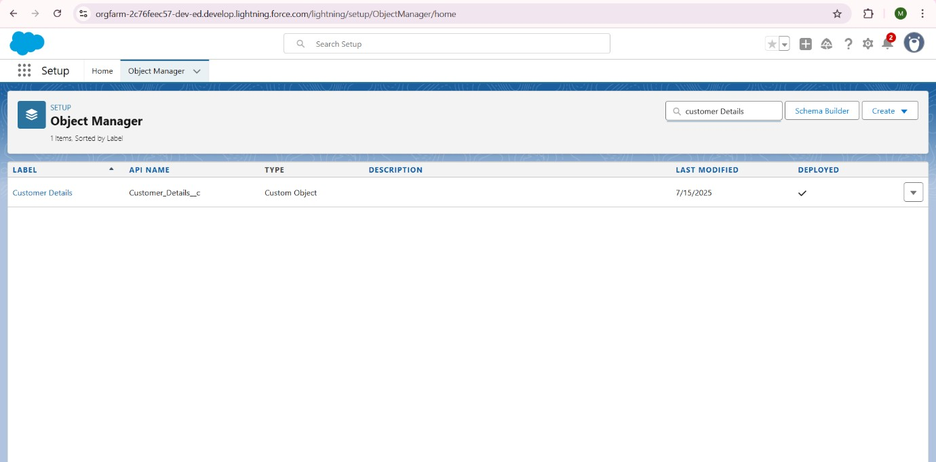

* + Here you can observe,***Customer Details*** object,with its Details like Fields and Relationships,Page Layout,Validation Rules,Field Set etc..

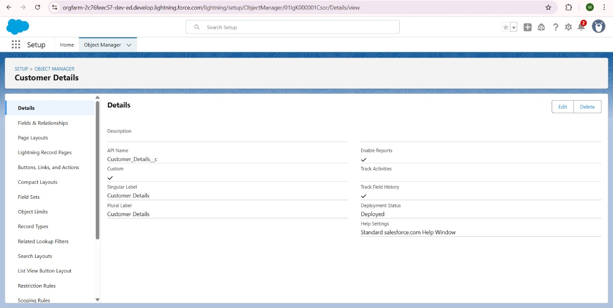

* + In ***Fields & Relationships*** ,where you can **Create**,**View** ,**Edit** Custom objects that you Created.

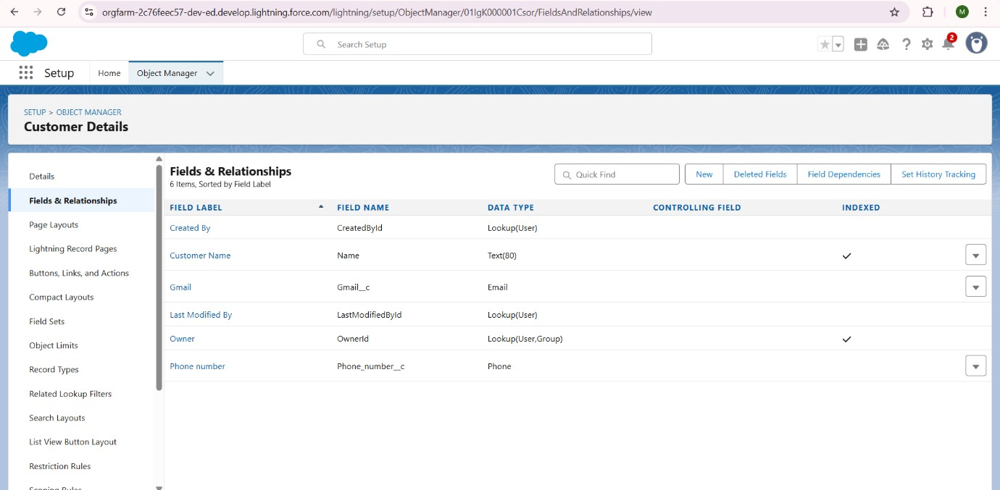

* + To create new Field in customer object (eg,GMail ),click on New and select Datatype as Email,then click on Next ,select all in Visibility ,leave as before Readonly,Next,Next.

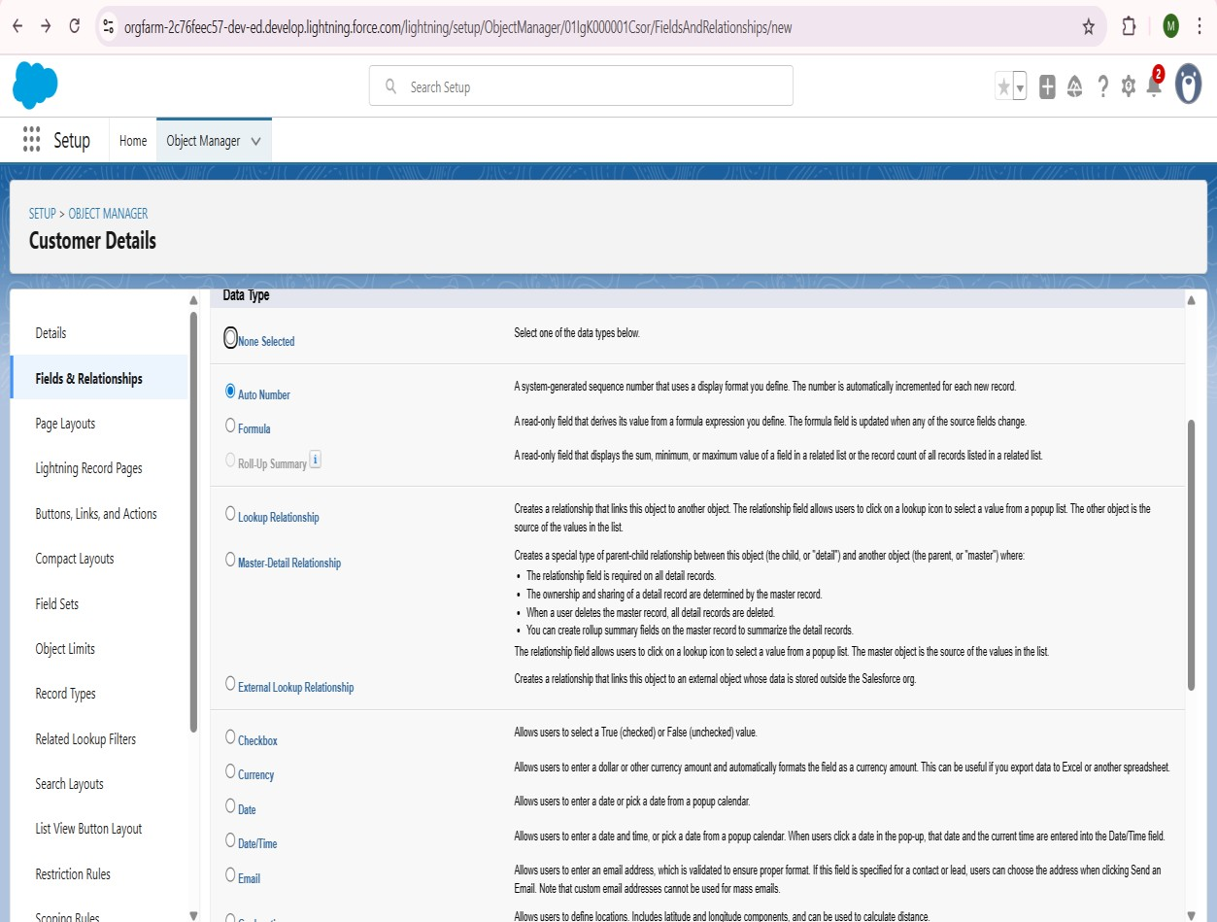

* + LikeWise,Create Fields such as **Customer Name**,**Phone number** in ***Customer Object.***

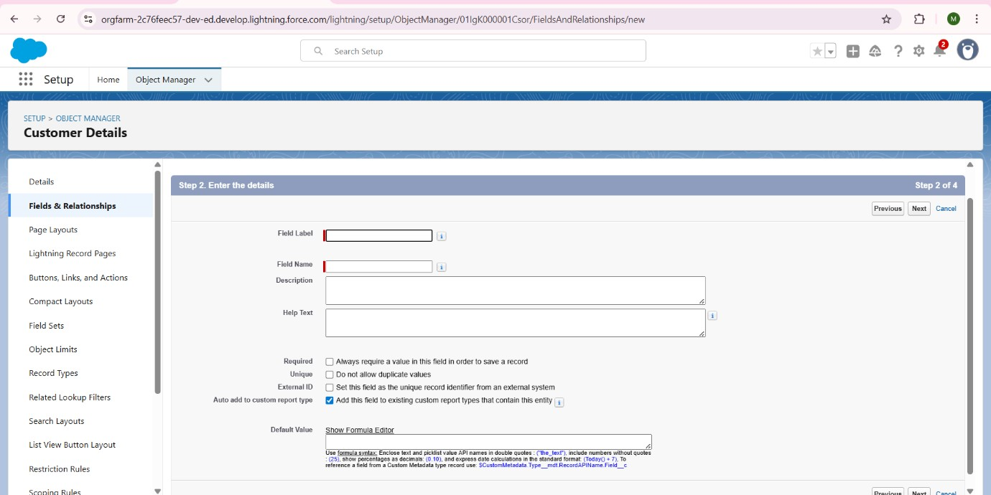

* + **Appointment:** Fields for Appointment Date (Date), Vehicle number plate (Text), Maintenance service (Checkbox), Repairs (Checkbox), Replacement Parts (Checkbox), Service Amount (Currency). Lookup to Customer Details.

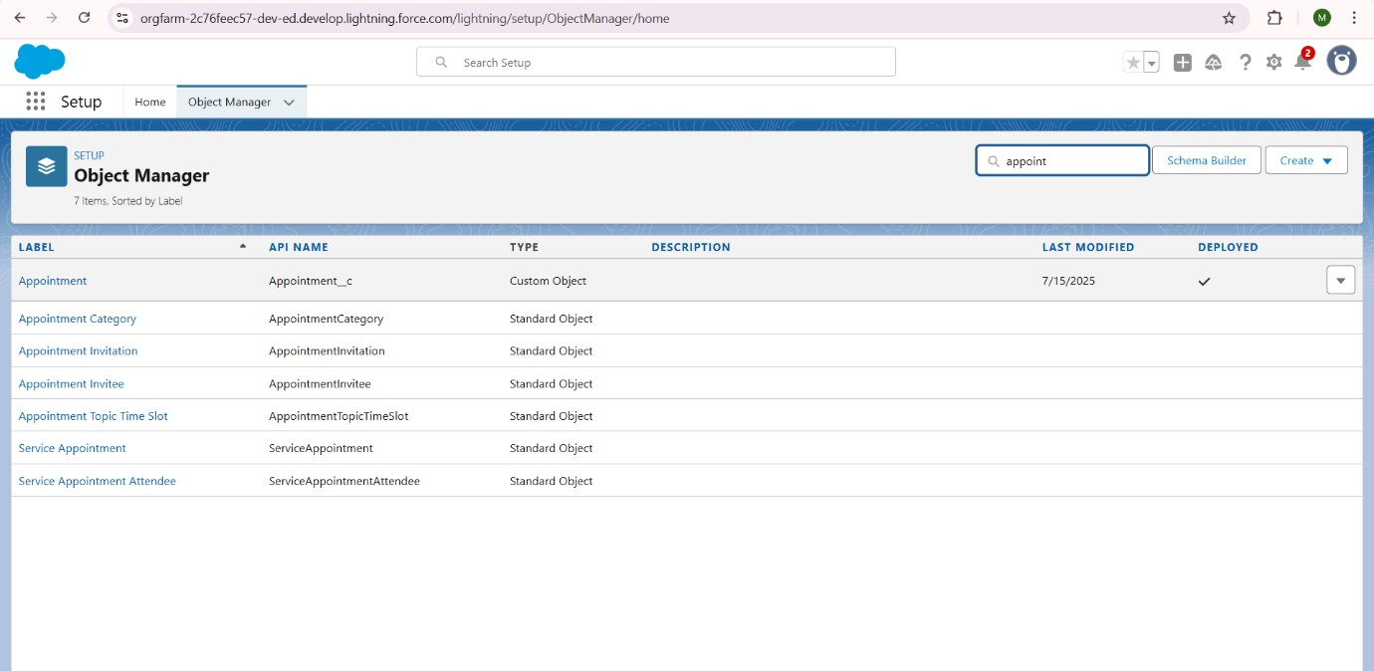

* + Create Field in ***Appointment*** object by clicking ***Object Manager***,Search ***Appoinment,***

Go to ***Fields & Relationships*** then Create Fields such as ***Appointment***

***Date(Date),Appointment Name(Auto Number),Maintenace***

***Service(Checkbox),Repairs(Checkbox),Replacement Parts(Checkbox),Vehicle number plate(Text),Service Amount(Currency).***

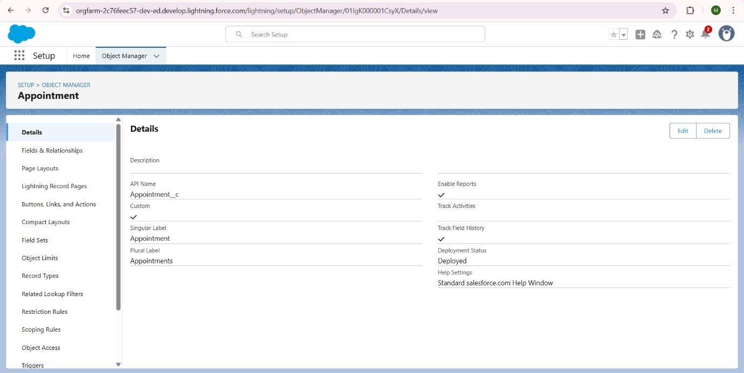

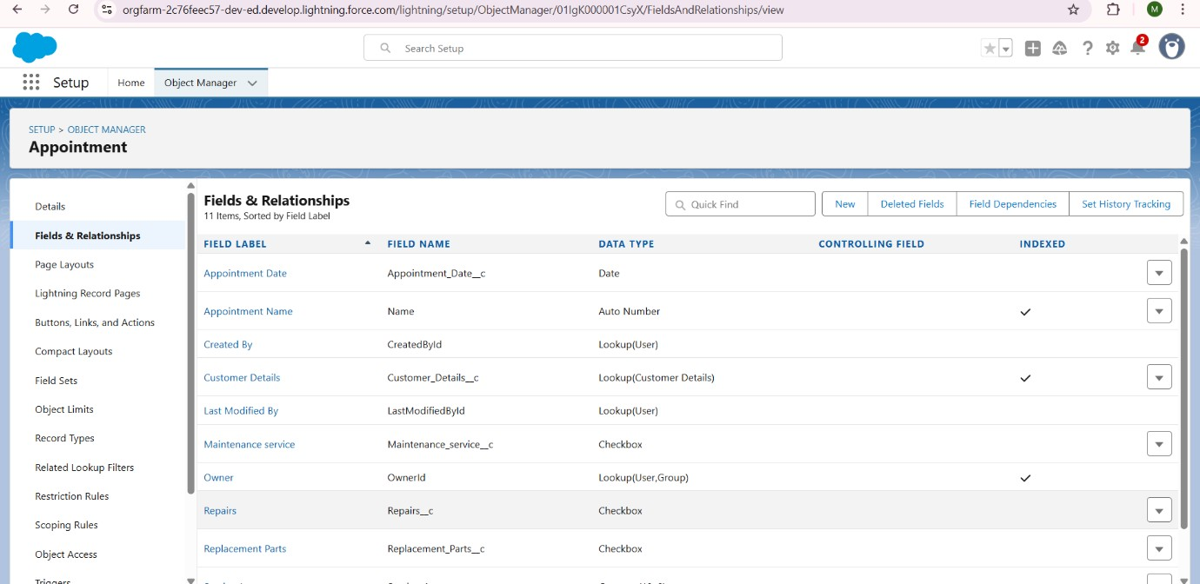

* + **Service records:** Fields for Service Status (Picklist), Quality Check Status (Checkbox). Lookup to Appointment.

* + Create Fields in ***Service Records*** such as ***Quality Check Status(Checkbox), Service date(Formula(Date)),Service Record Name(Auto number),Service Status(picklist).***

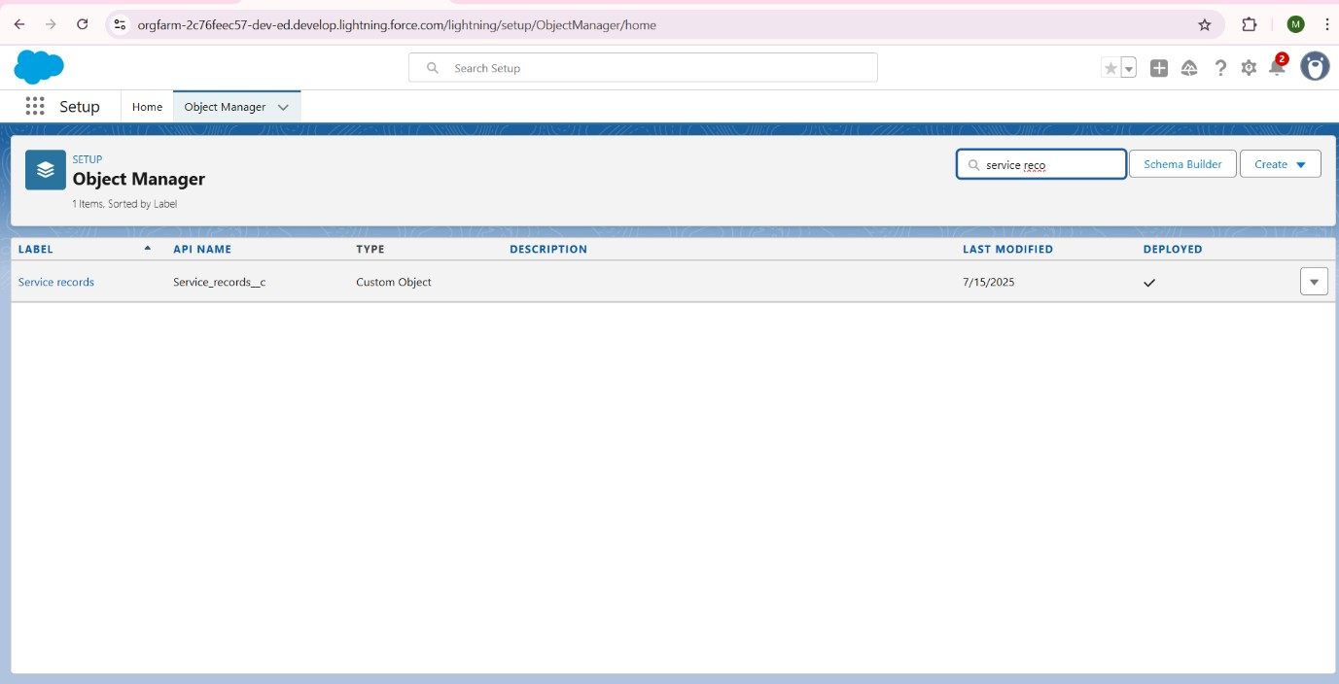

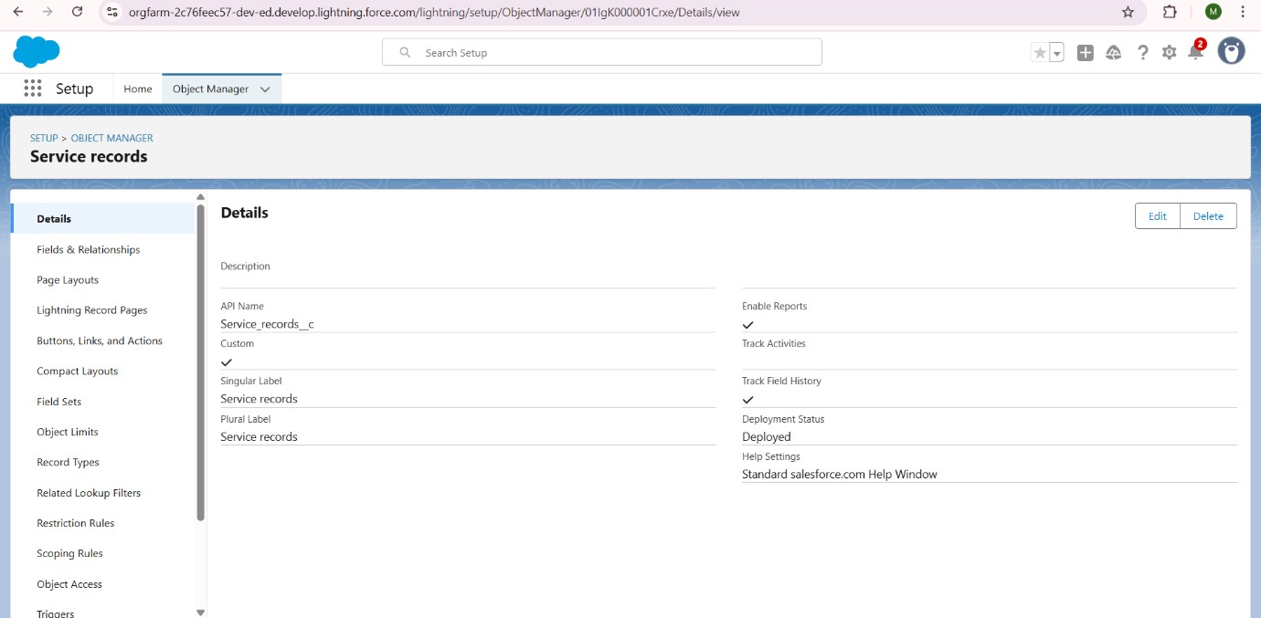

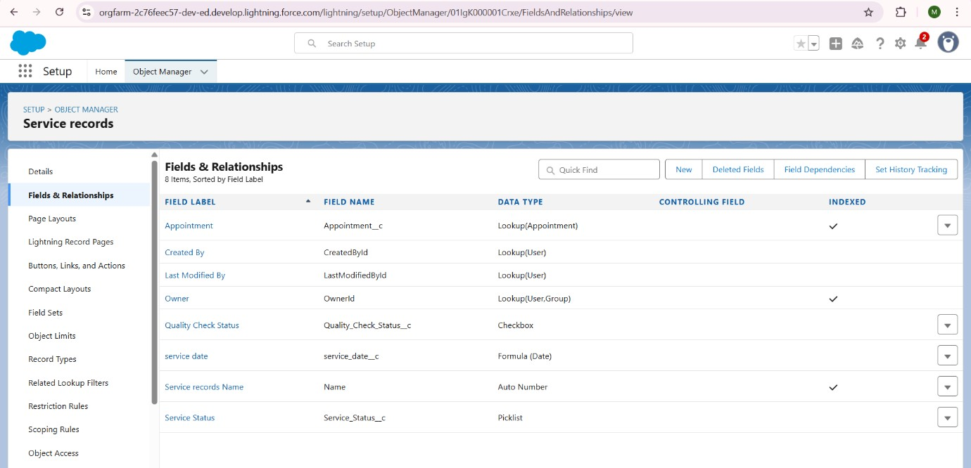

* + **Billing details and feedback**: Fields for Payment Paid (Currency), Payment Status (Picklist), Rating for service (Text). Lookup to Service Records.

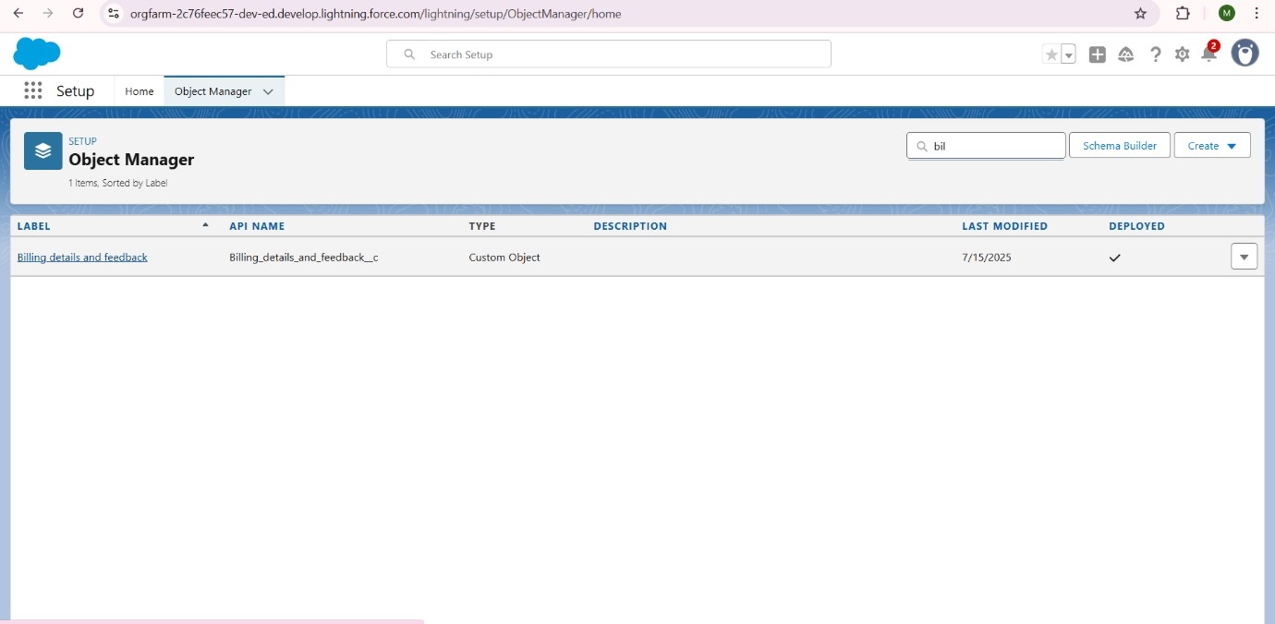

* + Create Fields Such a ***Billing details and feedback Name***(***Auto Number),Payment***

***Paid(Currency),Payment Status(Picklist),Rating for Service (Text),Service Records(Lookup)***

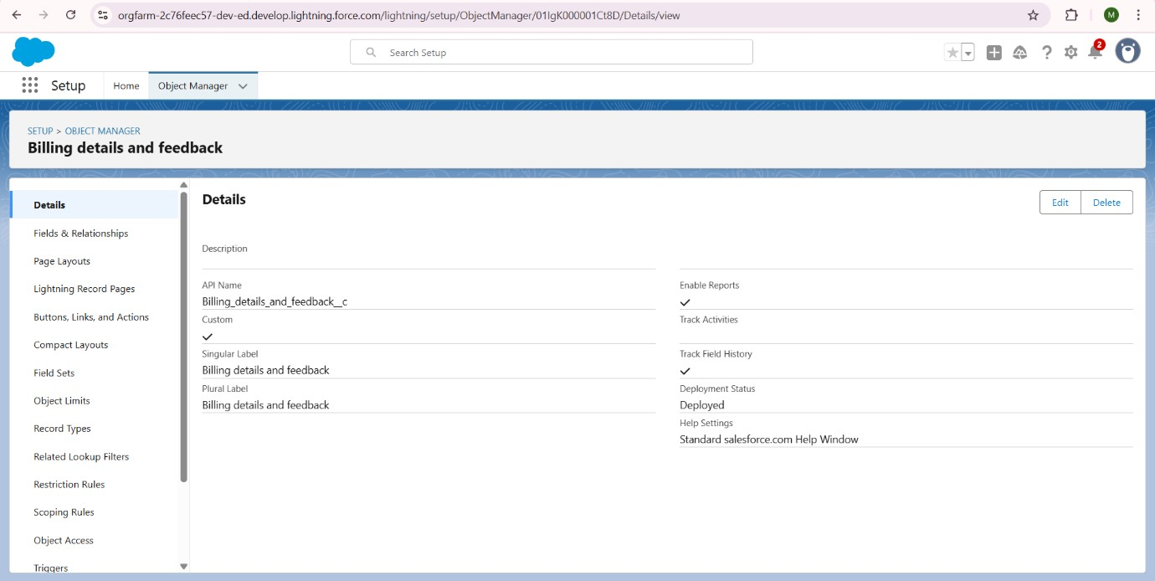

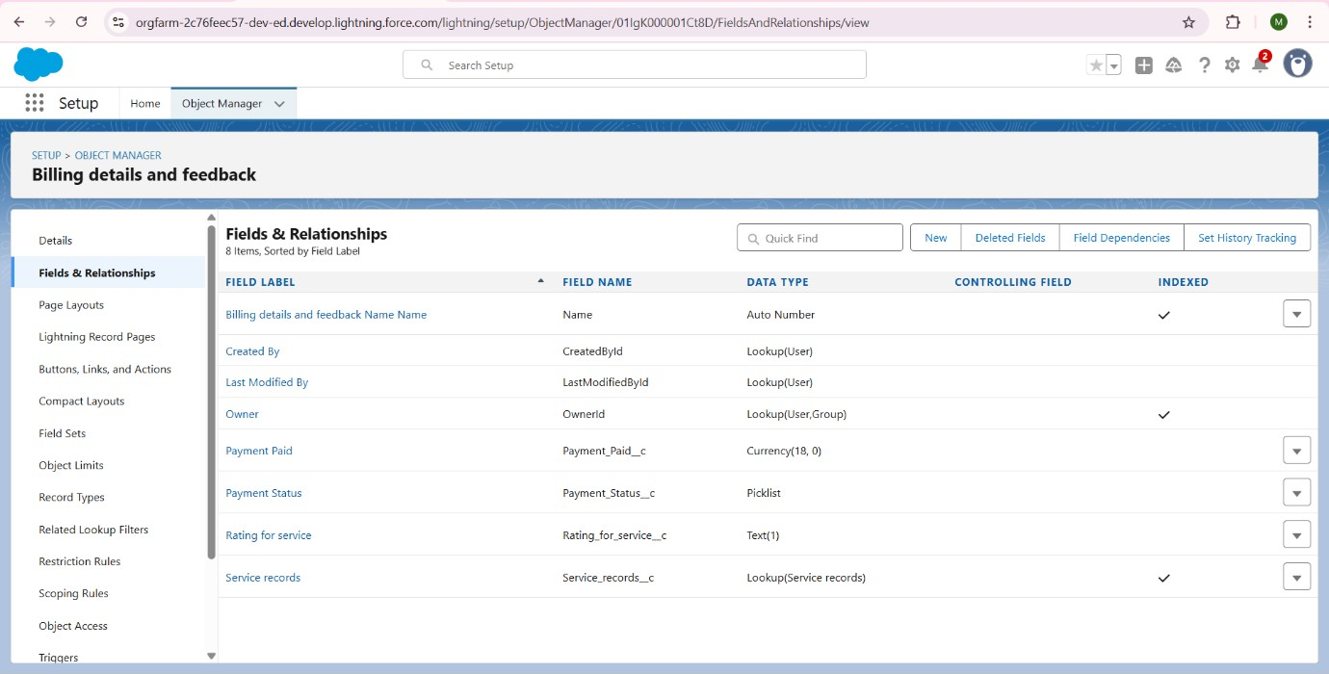

**Validation Rules:**

* + **Appointment Object - Rule Name: Vehicle**
    - * **Purpose:** Ensures the Vehicle_number_plate__c field adheres to a strict format (e.g., AA00AA0000).
      * **Error Condition Formula:** NOT(REGEX( Vehicle_number_plate__c , "[AZ]{2}[0-9]{2}[A-Z]{2}[0-9]{4}")) o **Error Message:** "Please enter valid number" o **Location:** Field (Vehicle_number_plate__c)

**Automation (Flows):**

**Creation Of Flows:**

1.click on **Home** tab, below you can see **Quick Find** search Box.

2.Search for ***Flows*** by Typing.

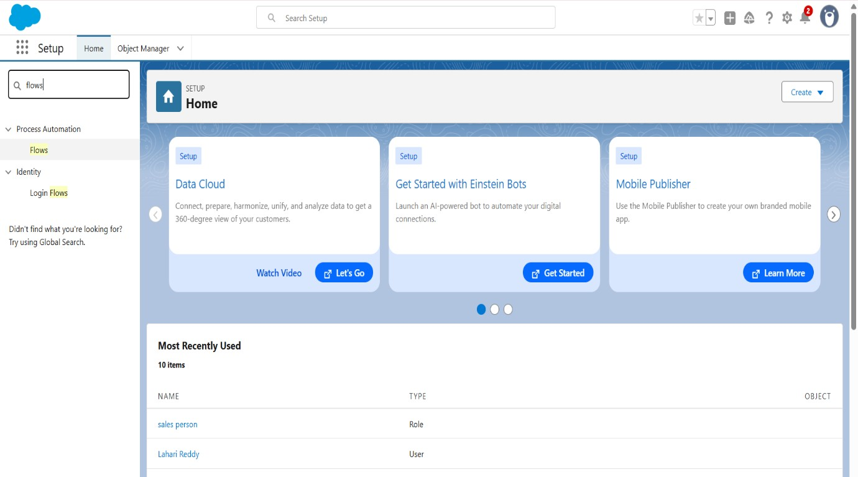

3.Here by clicking on **New Flow** you can create Flows.

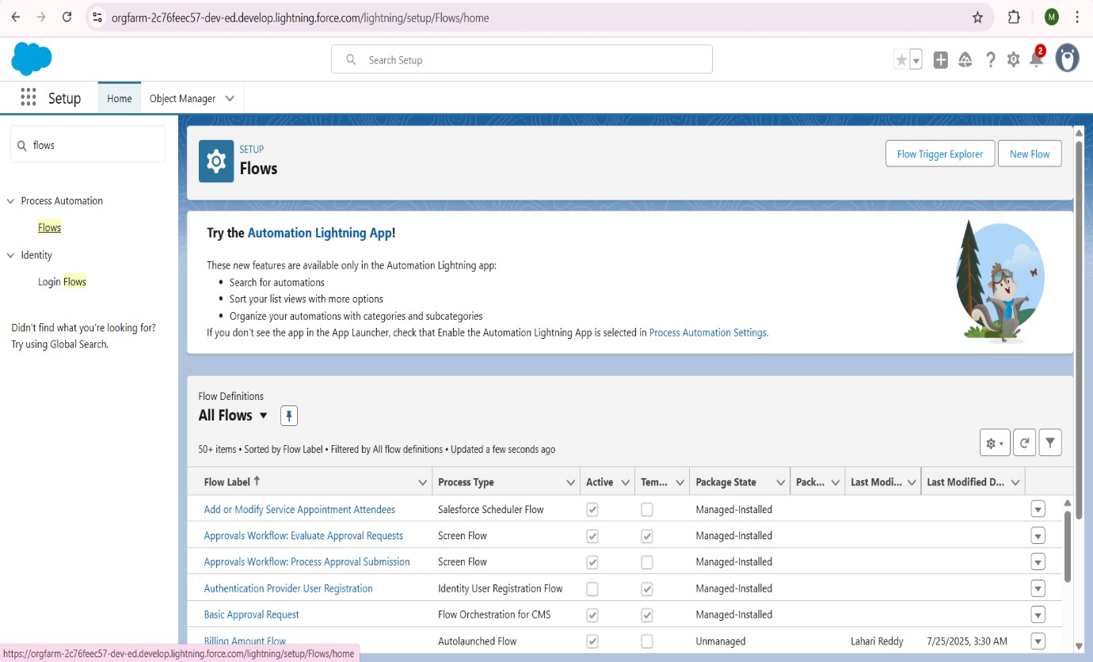

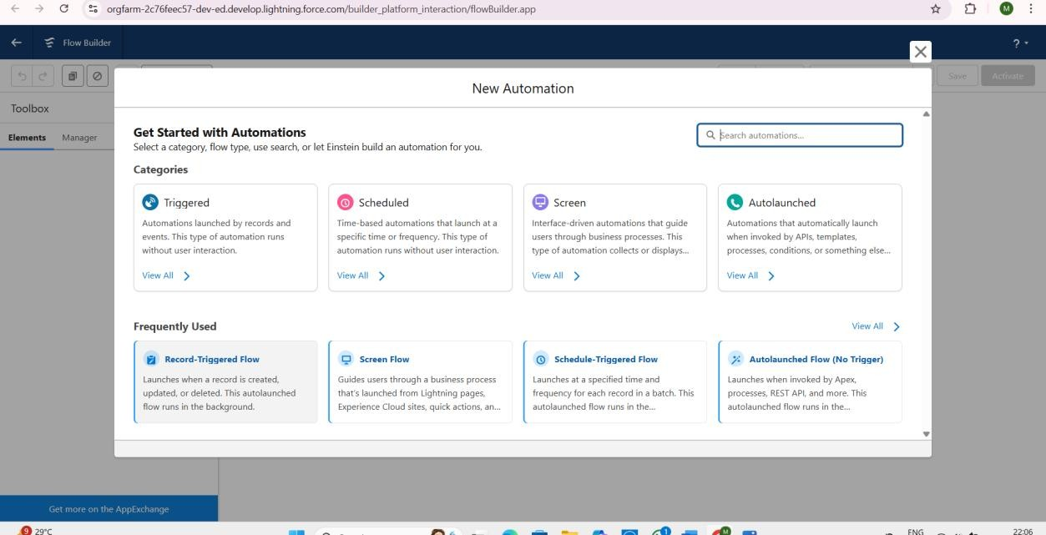

• **Flow Name: Billing Payment and Email Flow**

* **Type:** Record-Triggered Flow (on Billing details and feedback record creation or update).
* **Purpose:**
  1. **Amount Update:** When Payment_Status__c on a Billing details and feedback record is Completed, updates the Payment_Paid__c field to match the Service_Amount__c from the related Appointment record.
  2. **Email Alert:** Sends a thank-you email to the customer's Gmail address upon successful payment completion, including the paid amount.

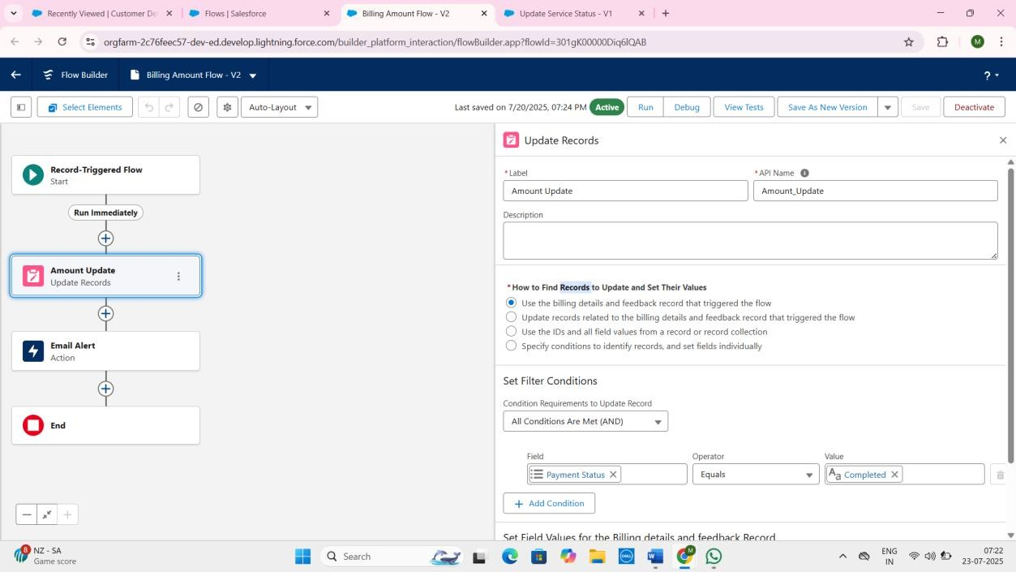

1. Select the Object as “Billing details and feedback”in the Drop down list.
2. Select the Trigger Flow when: “A record is Created or Updated”.
3. Select the Optimize the flow for: “Actions and Related Records” and Click on Done. 7. Under the Record-triggered Flow Click on “+” Symbol and In the Drop down List select the “Update records Element”.
4. Give the Label Name : **Amount Update** .

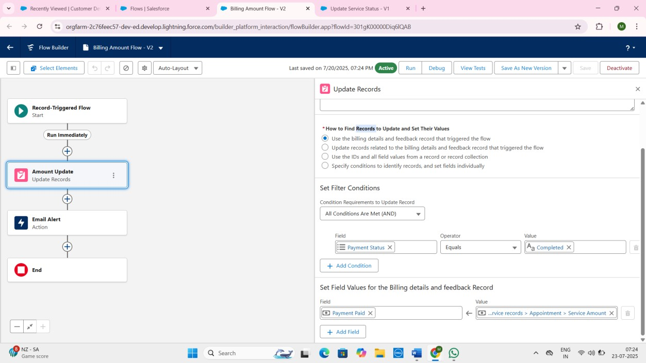

1. Set a filter condition : All Conditions are met(AND)
2. Field : Payment_Status__c
3. Operator : Equals
4. Value : Completed
5. And Set Field Values for the Billing details and feedback Record
6. Field : Payment_Paid__c
7. Value : {!$Record.Service_records__r.Appointment__r.Service_Amount__c}
8. Click On Done.
9. Before Creatng another Element, Create a New Resource form Toolbox from top left.
10. Click on the New Resource, And select Variable.
11. Select the resource type as text template.
12. Enter the API name as “ alert”.
13. Change the view as Rich Text ? View to Plain Text.
14. In body field paste the syntax that given below.

Dear {!$Record.Service_records__r.Appointment__r.Customer_Name__r.Name},

I hope this message finds you well. I wanted to take a moment to express my sincere gratitude for your recent payment for the services provided by our garage management team. Your prompt payment is greatly appreciated, and it helps us continue to provide top-notch services to you and all our valued customers. Amount paid : {!$Record.Payment_Paid__c}

Thank you for Coming .

1. Click done.
2. Now Click on Add Element , select Action.
3. Their action bar will be opened in that search for “ send email ” and click on it.
4. Give the label name as “ Email Alert”
5. API name will be auto populated.
6. Enable the body in set input values for the selected action.
7. Select the text template that created , Body : {!alert} 30. Include recipient address list select the email form the record.

31. RecipientAddressList:

{!$Record.Service_records__r.Appointment__r.Customer_Name__r.Gmail__c} 32. Include subject as “ Thank You for Your Payment - Garage Management”.

1. Click done.
2. Click on save.Give the Flow label,Flow Api name will be autopopulated.
3. And click save, and click on Activate.

**Flow Name: Update Service Status**

* + **Type:** Record-Triggered Flow (on Service records record creation or update).
  + **Purpose:** When the Quality_Check_Status__c checkbox on a Service records record is set to True, it automatically updates the Service_Status__c field to Completed.

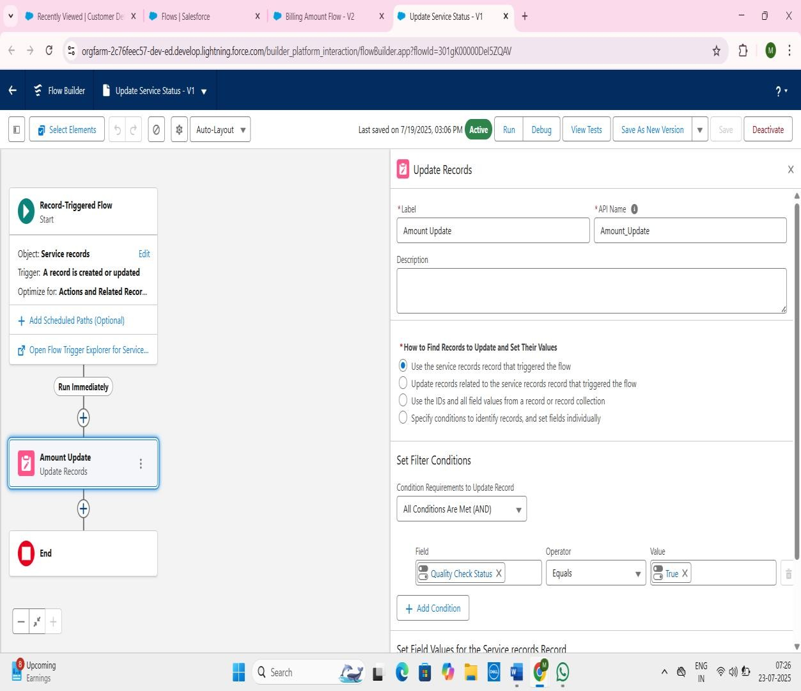

* 1. Go to setup ,type Flow in quick find box ,Click on the Flow and Select the New Flow.
  2. Select the Record-triggerd flow and Click on Create.
  3. Select the Object as “ Service records”in the Drop down list.
  4. Select the Trigger Flow when: “A record is Created or Updated”.
  5. Select the Optimise the flow for: “Actions and Related Records” and Click on Done.
  6. Under the Record-triggered Flow Click on “+” Symbol and In the Drop down List select the “Update records Element”.
  7. Set a filter condition : All Conditions are met(AND)
  8. Field : Quality_Check_Status__c
  9. Operator : Equals

10.Value : True

11.And Set Field Values for the Billing details and feedback Record

12.Field : Service_Status__c

13.Value : Completed

1. Click On Done.
2. Click on save
3. Given the Flow label as Update Service Status , Flow Api name will be auto populated.
4. And click save, and click on activate.

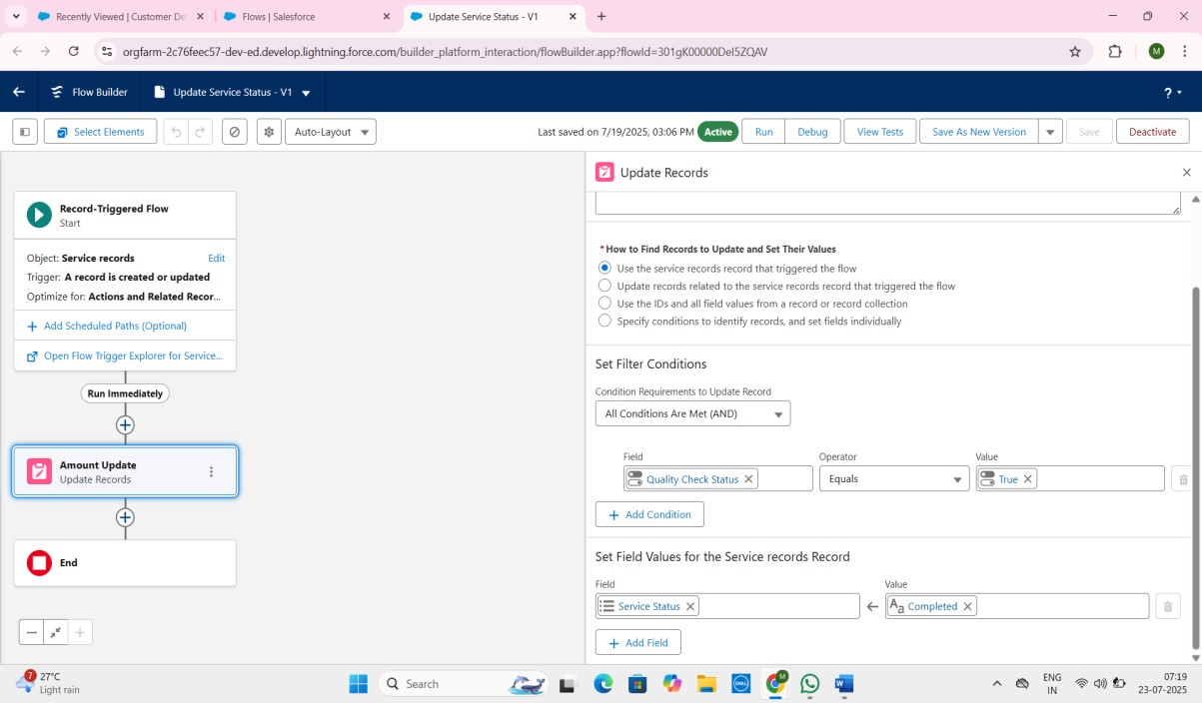

**4.3 Apex Classes & Triggers:**

• **Apex Class: AmountDistributionHandler**

o **Purpose:** Contains the core logic to calculate the Service_Amount__c on

Appointment__c records based on the selection of Maintenance_service__c, Repairs__c, and Replacement_Parts__c checkboxes. It applies predefined pricing tiers for various service combinations.

**Creation for Apex clases and Apex Triggers:**

* + - Go to Gear Icon, Click on **Developer Console**.
    - You can see the below Image.
    - To create **Apex Class**, click on **File,** click on **New, Apex Class.**
    - To create **Apex Trigger** click on **New** and click on **Apex Trigger.**

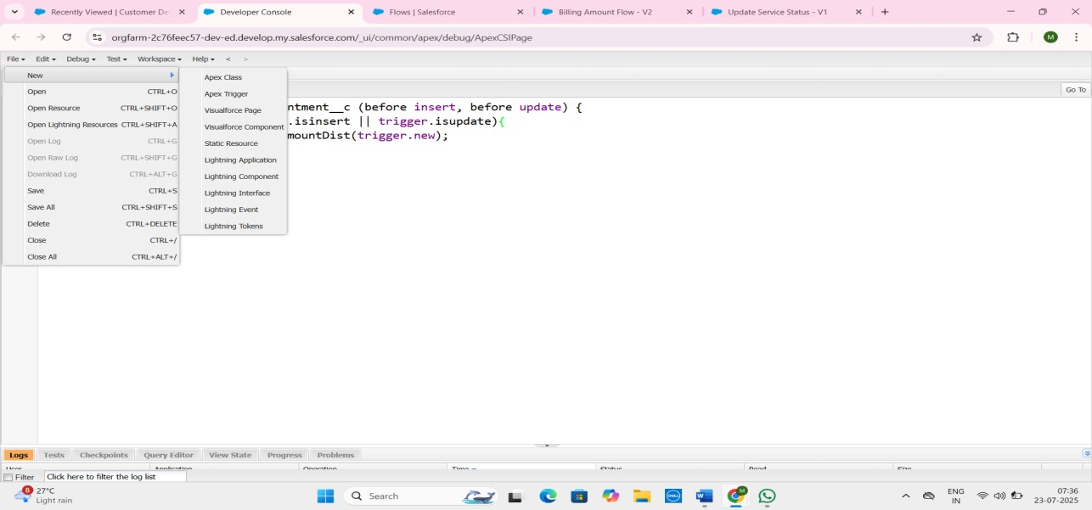

The ***AmountDistributionHandler*** Apex class is used to **automatically calculate and set the Service_Amount__c on Appointment records** based on selected service checkboxes, ensuring consistent pricing. It centralizes this business logic, keeping the trigger clean.

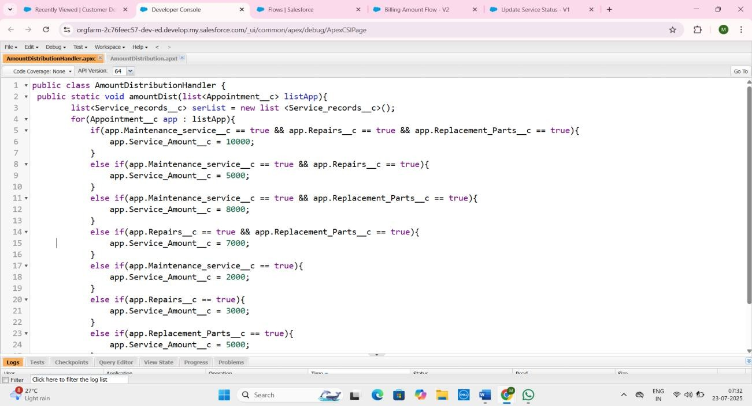

**Code:**

public class AmountDistributionHandler { public static void amountDist(list<Appointment__c> listApp){ list<Service_records__c> serList = new list <Service_records__c>(); for(Appointment__c app : listApp){

if(app.Maintenance_service__c == true && app.Repairs__c == true && app.Replacement_Parts__c == true){ app.Service_Amount__c = 10000;

}

else if(app.Maintenance_service__c == true && app.Repairs__c == true){ app.Service_Amount__c = 5000;

}

else if(app.Maintenance_service__c == true && app.Replacement_Parts__c == true){ app.Service_Amount__c = 8000;

}

else if(app.Repairs__c == true && app.Replacement_Parts__c == true){ app.Service_Amount__c = 7000;

}

else if(app.Maintenance_service__c == true){ app.Service_Amount__c = 2000;

}

else if(app.Repairs__c == true){ app.Service_Amount__c = 3000;

}

else if(app.Replacement_Parts__c == true){ app.Service_Amount__c = 5000;

}

}

}

}

**Apex Trigger: AmountDistribution**

* **Object:** Appointment__c
* **Events:** before insert, before update
* **Purpose:** Invokes the amountDist method from AmountDistributionHandler class. This ensures the Service_Amount__c is calculated and set *before* the Appointment record is saved to the database, making the amount immediately available.

Here's its role in your project:

* Its primary purpose is to **initiate the automatic calculation of the Service_Amount__c** for Appointment records.
* **Execution:** It fires **before insert** (when a new Appointment is being created) and **before update** (when an existing Appointment is being modified).
* **Mechanism:** It calls the AmountDistributionHandler.amountDist method, passing all the Appointment records that are currently being processed (Trigger.new). This ensures the Service_Amount__c field is populated with the correct calculated value *before* the record is finally saved to the database.

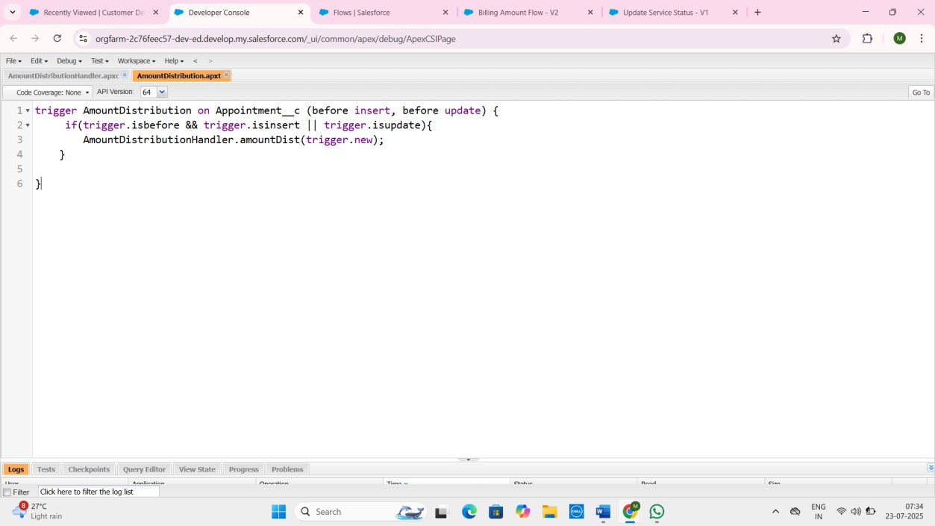

# 5. Phase 3: UI/UX Development & Customization

**5.1 Lightning App Setup:**

A custom Lightning App named Garage Management has been set up via App Manager. This app provides a tailored user experience with specific navigation items (tabs) relevant to the garage's operations, including: Customer Details, Appointments, Billing details and feedback, Reports, Dashboards, and Service records.

* A **Lightning App** in Salesforce is a collection of items (tabs, objects, Lightning components, utilities) that work together to serve a specific business purpose or role within your organization.

**Purpose of a Lightning App:**

* **Tailored User Experience (UX):** It focuses the user's attention on the specific objects and tools they need for their particular tasks.
* **Increased Productivity:** By minimizing clutter and providing direct access to relevant items, it helps users work more efficiently.
* **Branding and Identity:** You can customize the app's logo, colors, and branding to align with your company's identity.
* **Organized Navigation:** It provides a clear navigation bar with tabs for easy access to the most important objects and pages.

**Key Components of a Lightning App:**

* **Navigation Items (Tabs):** These are the core of the app, typically representing objects (like your "Customer Details" or "Appointments" tabs), but can also be Lightning pages, external websites, or utility bar items.
* **Utility Bar:** A persistent footer that allows users quick access to common tools (e.g., dialer, notes, recent items) regardless of where they are in the app.
* **Branding:** Custom logo, header color, and user interface color.
* **My Domain:** Essential for branding and enabling many Lightning Experience features.

A **Lightning App** in Salesforce is a collection of items (tabs, objects, Lightning components, utilities) that work together to serve a specific business purpose or role within your organization.

Think of it as a **customized workspace** or a tailored interface that provides users with everything they need to perform their jobs efficiently, without distractions from irrelevant features.

**Purpose of a Lightning App:**

* + **Tailored User Experience (UX):** It focuses the user's attention on the specific objects and tools they need for their particular tasks.
  + **Increased Productivity:** By minimizing clutter and providing direct access to relevant items, it helps users work more efficiently.
  + **Branding and Identity:** You can customize the app's logo, colors, and branding to align with your company's identity.
  + **Organized Navigation:** It provides a clear navigation bar with tabs for easy access to the most important objects and pages.

**Key Components of a Lightning App:**

* + **Navigation Items (Tabs):** These are the core of the app, typically representing objects (like your "Customer Details" or "Appointments" tabs), but can also be Lightning pages, external websites, or utility bar items.
  + **Utility Bar:** A persistent footer that allows users quick access to common tools (e.g., dialer, notes, recent items) regardless of where they are in the app.
  + **Branding:** Custom logo, header color, and user interface color.
  + **My Domain:** Essential for branding and enabling many Lightning Experience features.

***"Garage Management System":***

In your project, you created a **"Garage Management" Lightning App**.

* + This app serves as the central hub for all users (Managers, Sales Persons) to interact with your custom CRM.
  + Its navigation bar prominently features the custom objects essential for your garage's operations:

o **Customer Details** o **Appointments** o **Billing details and feedback** o **Service records** o Along with standard Salesforce reporting tools like **Reports** and **Dashboards**

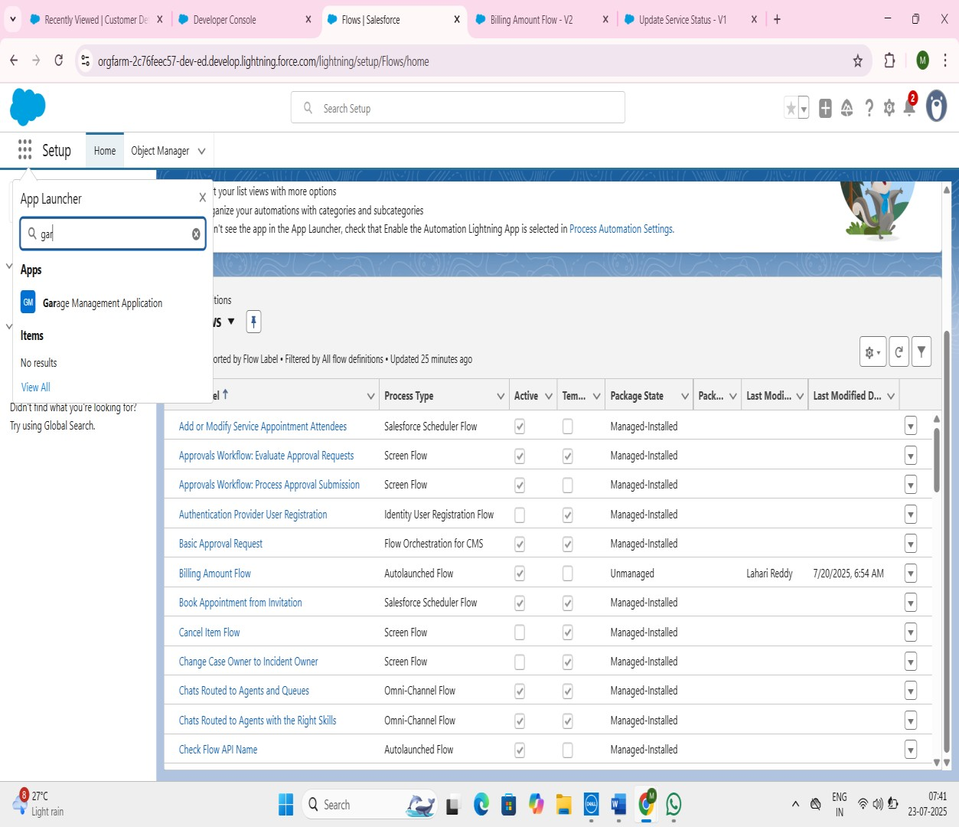

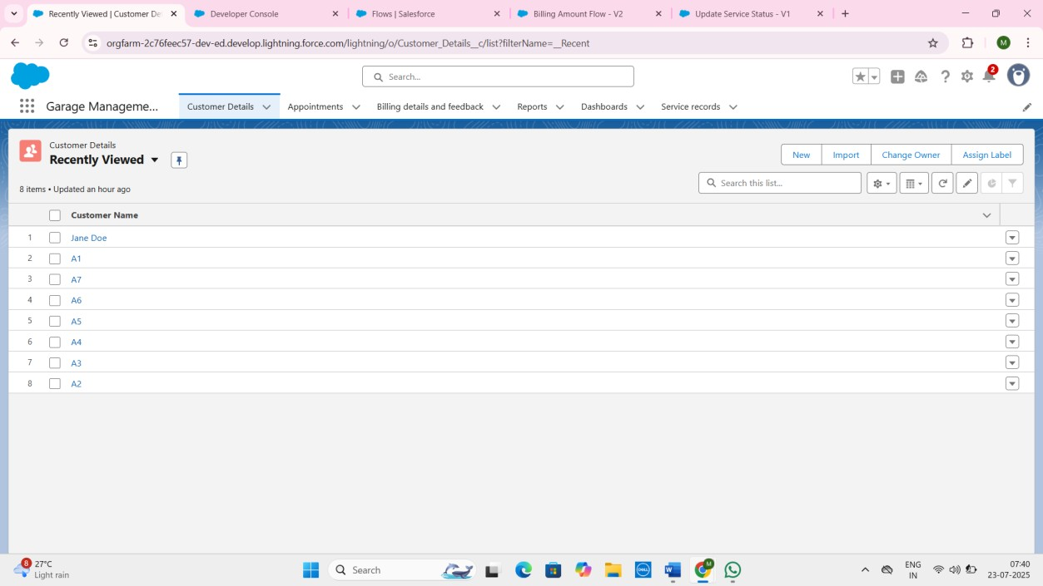

**5.2 Page Layouts, Dynamic Forms:**

Standard page layouts are utilized for custom objects. Customizations have been made to arrange fields logically, ensuring key information is easily accessible. (If Dynamic Forms were specifically used on Lightning Record Pages, mention that here and how they improve the UI).

**5.3 User Management:**

Users are managed within Salesforce, with specific roles and profiles assigned to control access and data visibility.

**5.4 Reports and Dashboards:**

* + **Report Folder:** Garage Management Folder has been created to organize all reports related to the system.
  + **Dashboard Folder:** Service Rating dashboard has been created to organize key performance dashboards.
  + **Reports:**
    - **New Service Information Report:** Provides detailed information on services, payments, and customer details.
    - **Custom Report Type (Service information):** Created to enable reporting across Customer details, Appointments, Service records, and Billing details and feedback, allowing for comprehensive analysis.

o

➢ **Creating A Report Folder:**

1. Click on the app launcher and search for reports.
2. Click on the report tab, click on new folder.
3. Give the Folder label as “Garage Management Folder”, Folder unique name will be auto populated.
4. Click Save.

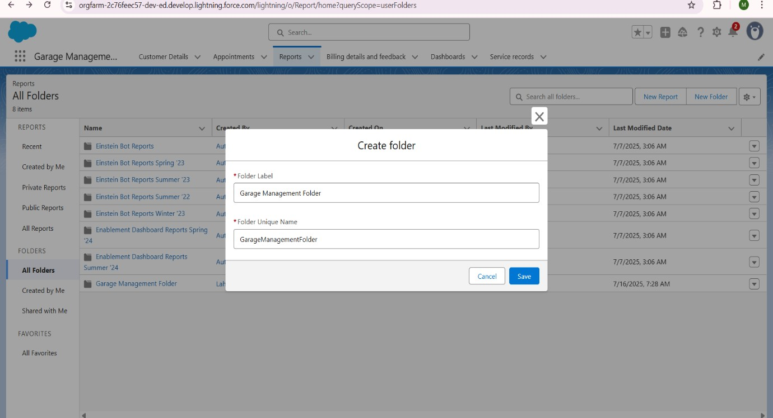

5.Click on “Garage Management Folder” open.

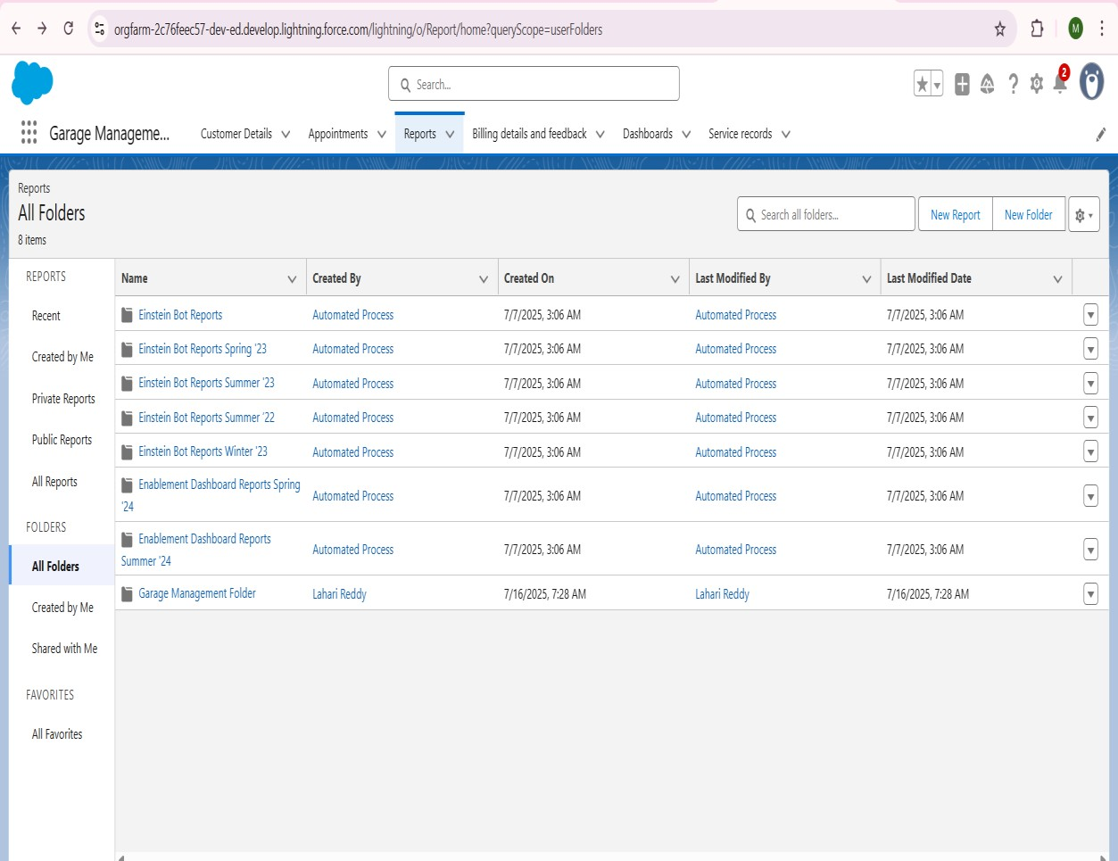

* + **Sharing A Report Folder**
  1. Go to the app >> click on the reports tab.
  2. Click on the All folder , click on the Drop down arrow for Garage Management folder, and Click on share.

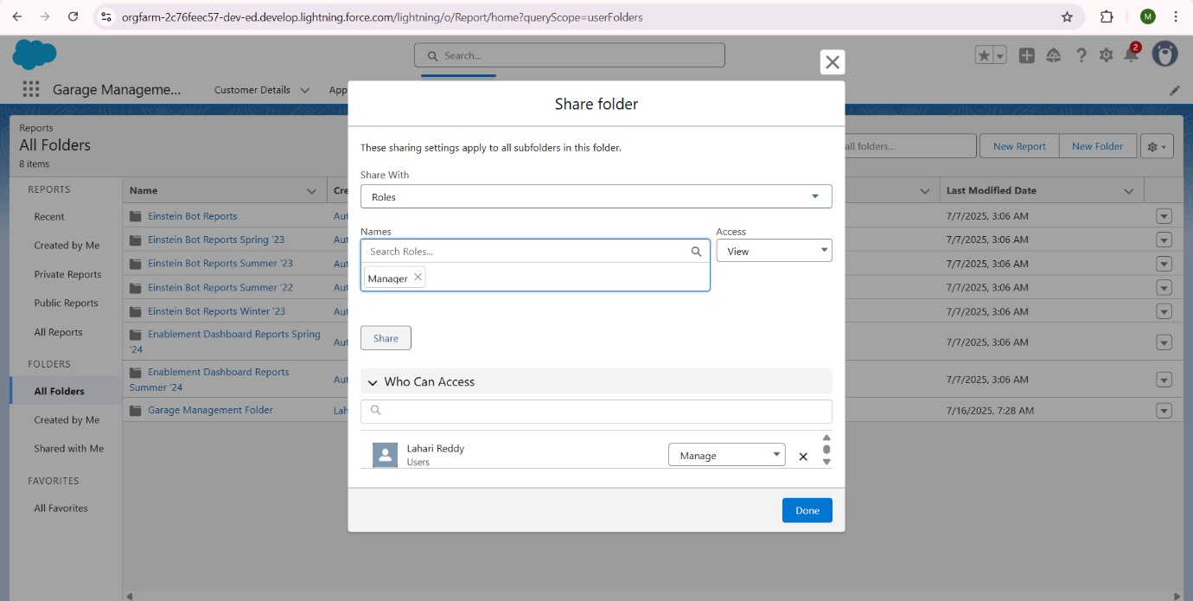

* 1. Select the share with as “roles”, in name field search for “manager”, give “view” as access for that role.
  2. Then click share, and click on Done.



* + **Ceate a Report Type**

* 1. Go to setup >> type users in quick find box >> select Report Type >> click on Continue.
  2. Click on new custom report type.

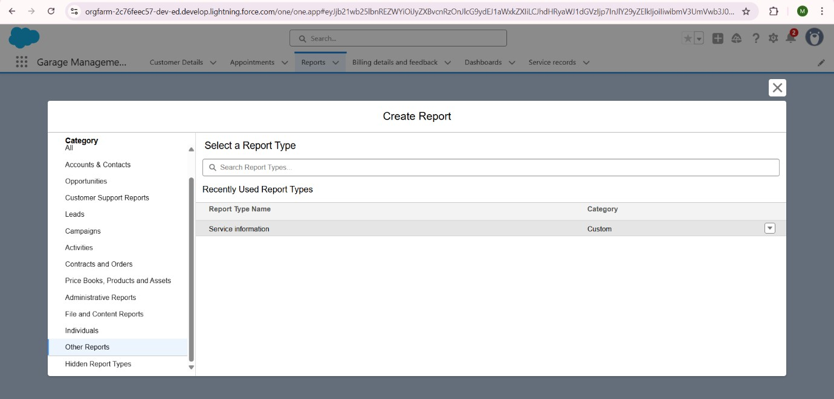

* 1. Select the Primary object as “ Customer details” .
  2. Give the Report type Label as “ Service information ”

1. Report type Name is autopopulated.
2. Keep the Description as same.
3. Select Store in Category as “ other Reports ”
4. Select the deployment status as “ Depolyed ”, click on Next.

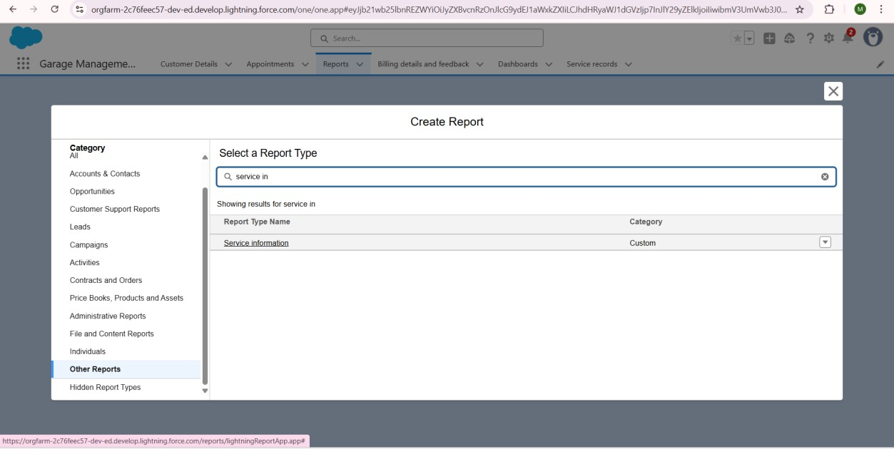

9.now, Click on Related object box.

10.Click on Select Object, Choose Appointment Object**.**

Again Click to relate another Object.

11.And Select the Related object as “Service Records”.

12.Repeat the Process and select the related object as “Billing details and feedback”.

13.And click on Save.

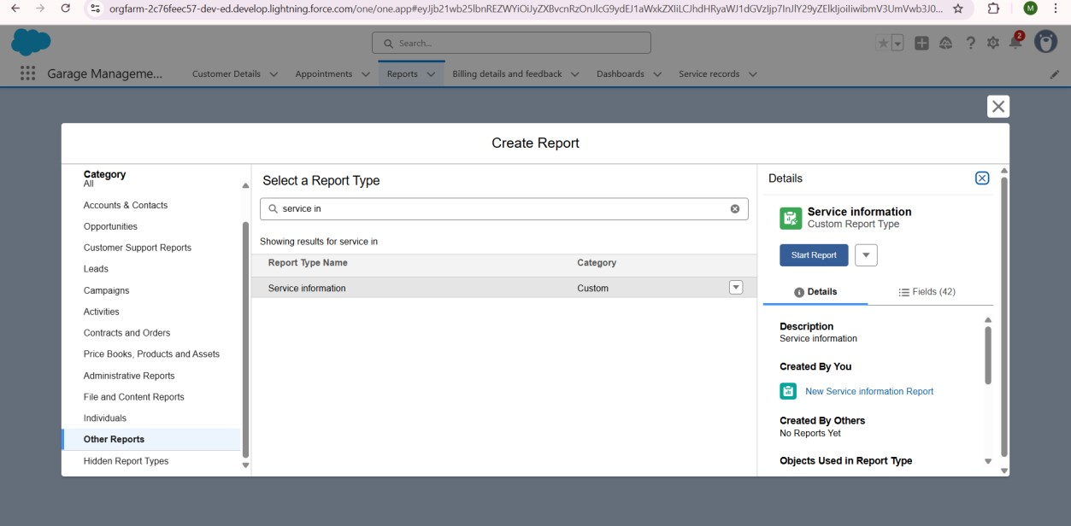

* + **Create Report**

• Create atleast 10 Records in each Objects.

1. Go to the app >> click on the reports tab 2. Click New Report.

* 1. Select the Category as other reports, search for Service Information, Select that report,Click on it.And Click on Start report.
  2. Their outline pane is opened alredy, select the fields that mentioned below in column section.
  3. Customer name
  4. Appointment Date
  5. Service Status
  6. Payment paid

5.. Remove the unnecessary fields.

6.Select the fields that mentioned below in GROUP ROWS section.

* + 1. Rating for Service

7.Select the fields that mentioned below in GROUP ROWS section.

* + 1. Payment Status

1. Click on Add Chart , Select the Line Chart.
2. Click on save, Give the report Name : New Service information Report
3. Report unique Name is auto populated.
4. Select the folder the created and Click on save.

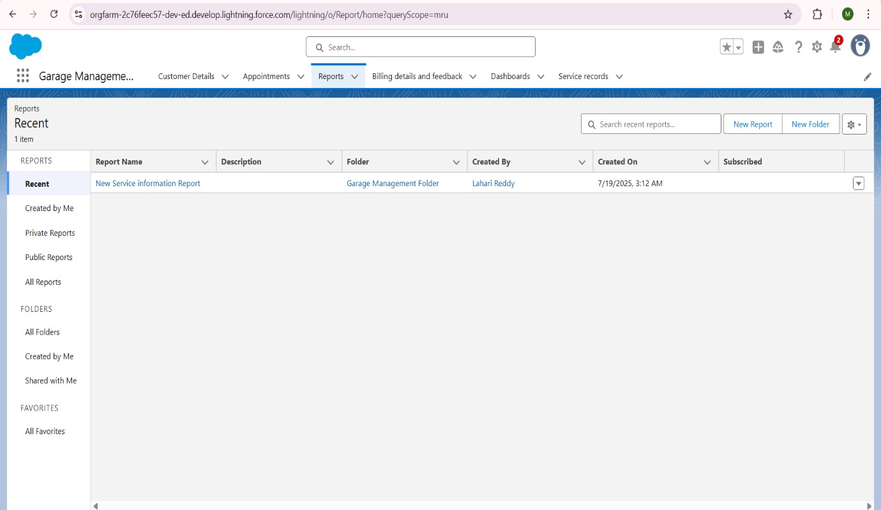

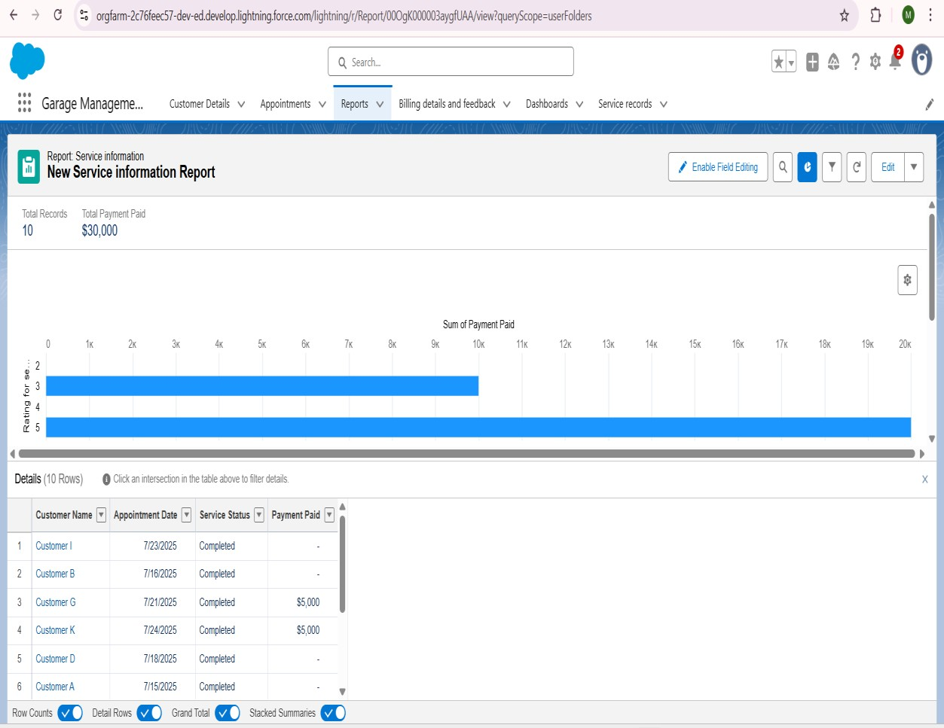

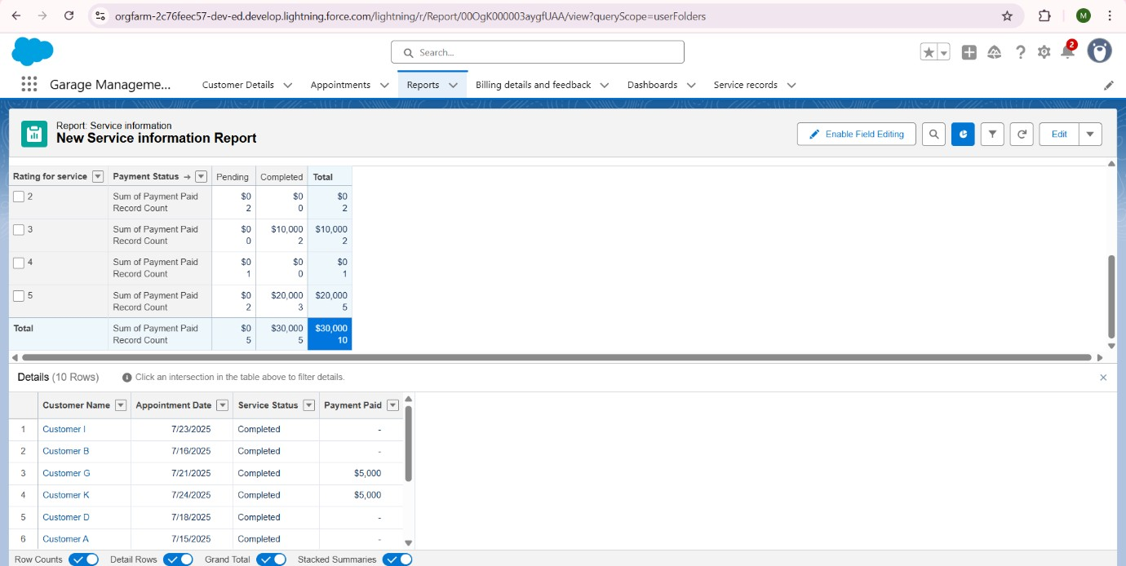

• **Dashboards:**

* + **Customer Review Dashboard:** Visualizes key metrics such as "Sum of Payment Paid" by "Rating for service" and payment status, providing quick insights into customer satisfaction and financial performance.
  + **Subscription:** The dashboard is subscribed to receive weekly email updates (e.g., every Monday).

**Create Dashboard Folder**

* 1. Click on the app launcher and search for dashboard.
  2. Click on dashboard tab.
  3. Click new folder, give the folder label as “ Service Rating dashboard”.
  4. Folder unique name will be auto populated.
  5. Click save.

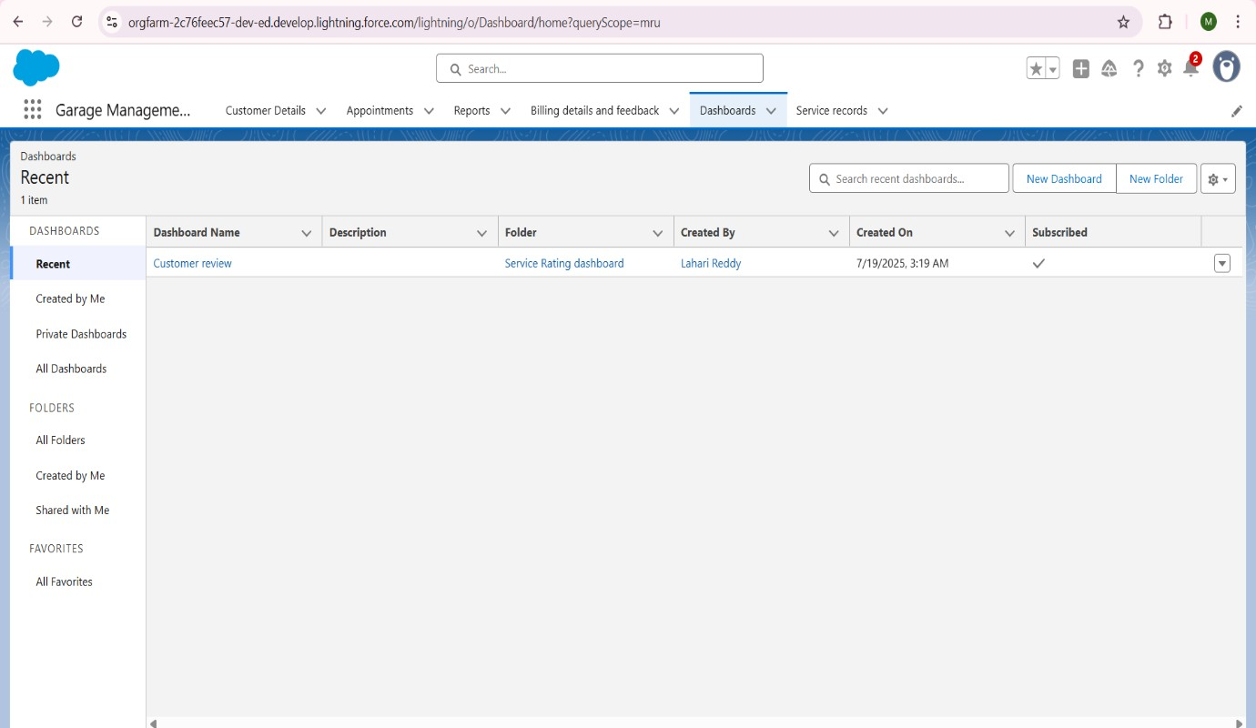

6.Follow the same steps,from Reports Milestone ,and Provide the Sharng Settngs for the Folder that was Just Created.

**Create Dashboard**

* 1. Go to the app >> click on the Dashboards tabs.
  2. Give a Name and select the folder that created, and click on create.
  3. Select add Component.
  4. Select a Report and Click on Select.
  5. Select the Line Chart. Change the theme.
  6. Click Add then click on Save and then click on Done.
  7. Preview is shown below.
  8. After that Click on Subcribe on top right.
  9. Set the Frequency as “ weekly ”.
  10. Set a day as monday.
  11. And Click on save.

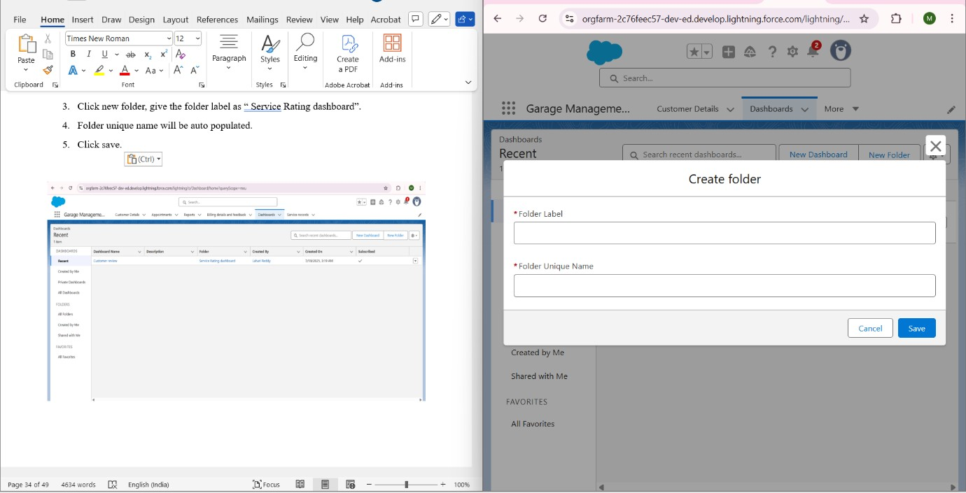

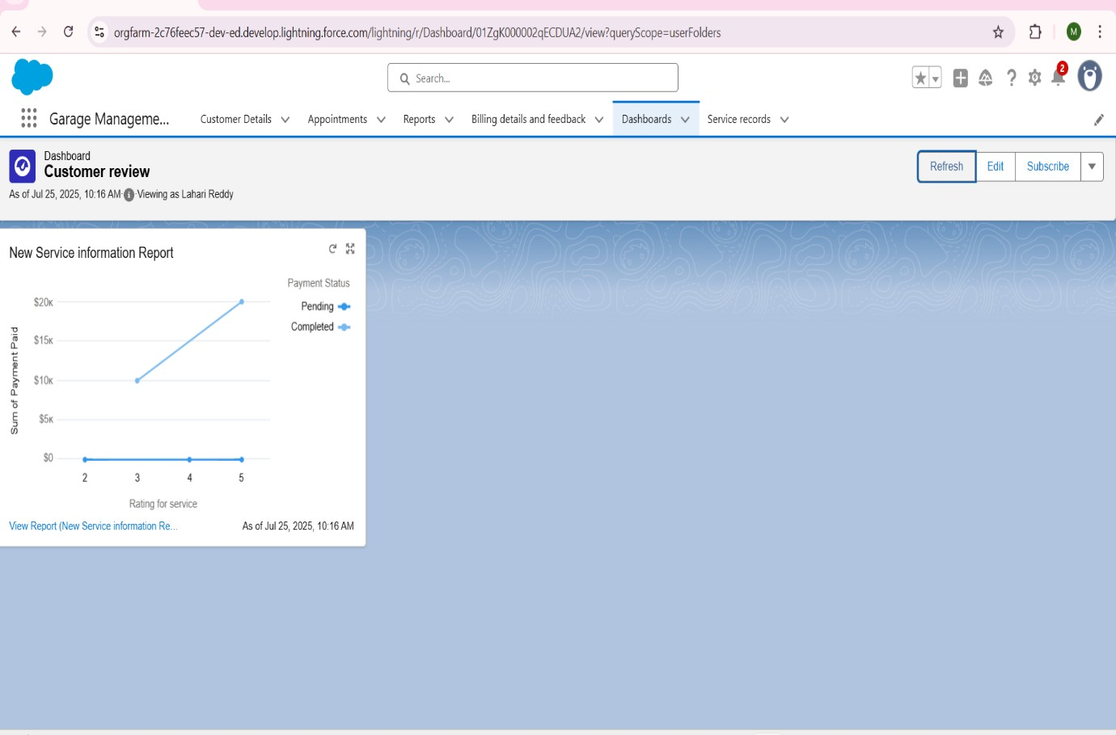

1. **Phase 4: Data Migration, Testing & Security** 
   1. **Data Loading Process:**

Initial data loading for Customer Details, Appointments, etc., can be performed using Salesforce's **Data Import Wizard** for smaller datasets or **Data Loader** for larger, more complex migrations.

* 1. **Data Quality & Integrity:** 
     + **Field History Tracking:** (If enabled on any key fields for auditing, mention it here).
     + **Duplicate Rules:**

o **Matching Rule Name: Matching customer details**

* + - * + **Object:** Customer details
        + **Purpose:** Identifies potential duplicate Customer details records where Gmail and Phone number fields have an Exact match.

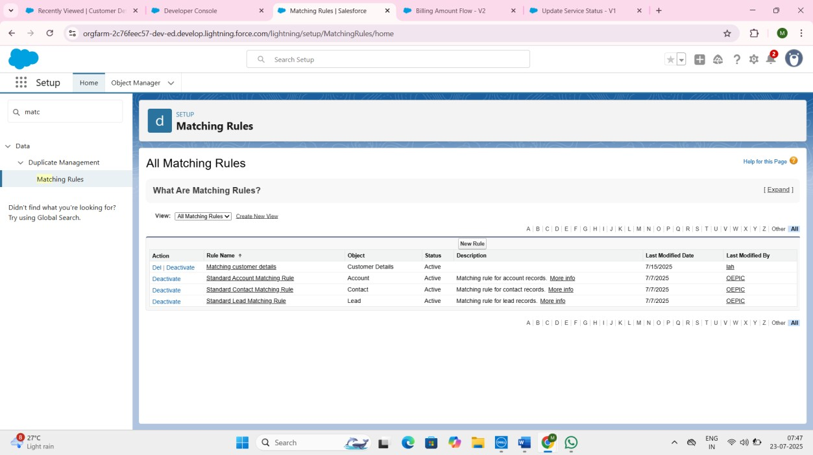

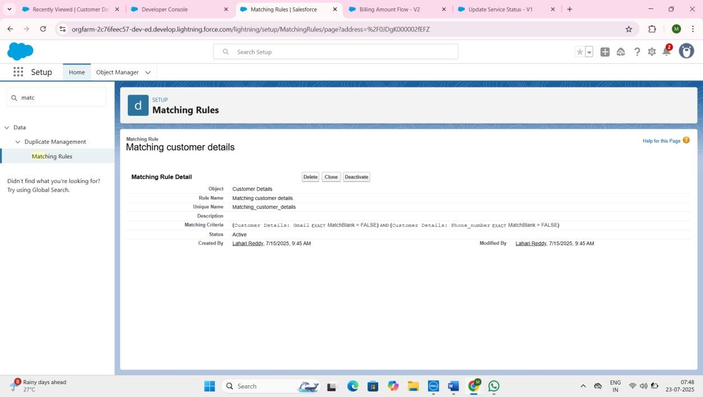

(Note: A **Duplicate Rule** (which uses this matching rule to either Block or Alert users) would be required to actively prevent or warn about duplicates. This was designed for future implementation based on the matching rule foundation.)

* 1. **Security Model Components:** 
     + **Profiles:**

o **Manager Profile:** Cloned from Standard User.

* + - * + **Custom App Settings:** Garage Management set as Default.
        + **Custom Object Permissions:** Full Read, Create, Edit, Delete, View All, Modify All access for Appointments, Billing details and feedback, Service records, and Customer details.
        + **Session Timeout:** 8 hours of inactivity.
        + **Password Policies:** Never expires, Minimum password length 8.

➢ **Manager Profile**

**To create a new profile:**

1. Go to setup >> type profiles in quick find box >> click on profiles >> clone the desired profile (Standard User) >> enter profile name (Manager) >> Save. 2.While still on the Profile page,then click Edit.

3.Select the Custom App Settings as default for the Garage management.

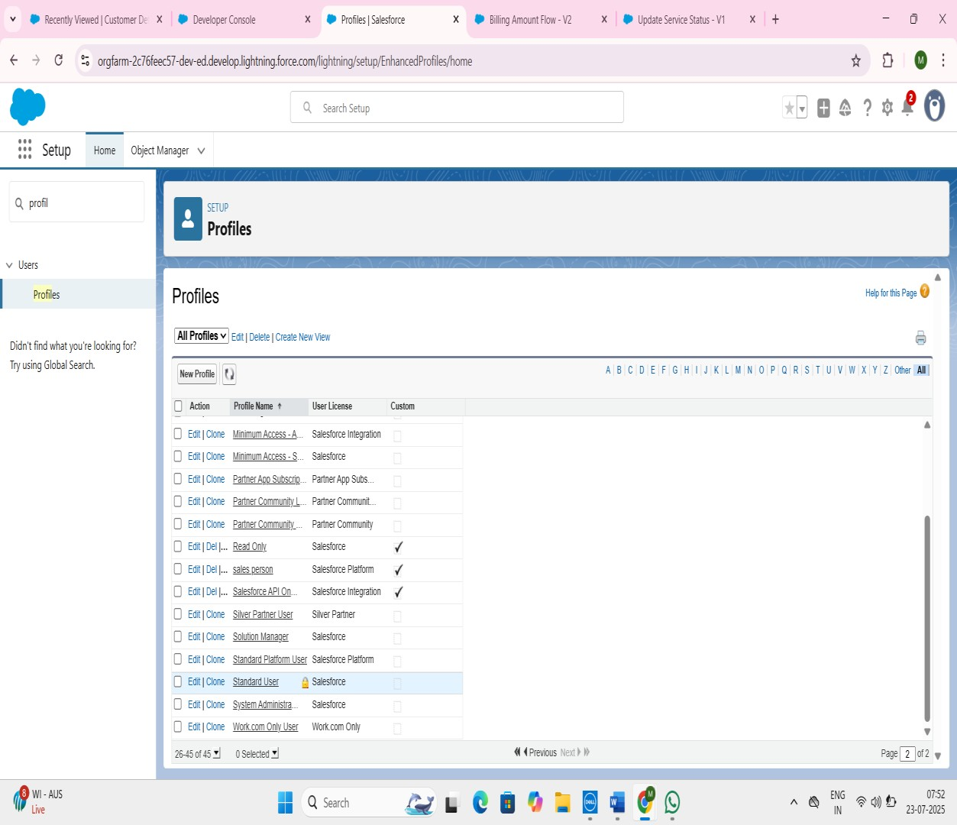

4.Scroll down to Custom Object Permission and Give access permission for Appointments, Billing details and feedback,servce records and customer details objects as mentioned in the below.

Changing the session times out after should be “ 8 hours of inactivity”.

5.Change the password policies as mentioned :

6.User passwords expire in should be “ never expires ”.

7.Minimum password length should be “ 8 ”, and click save.

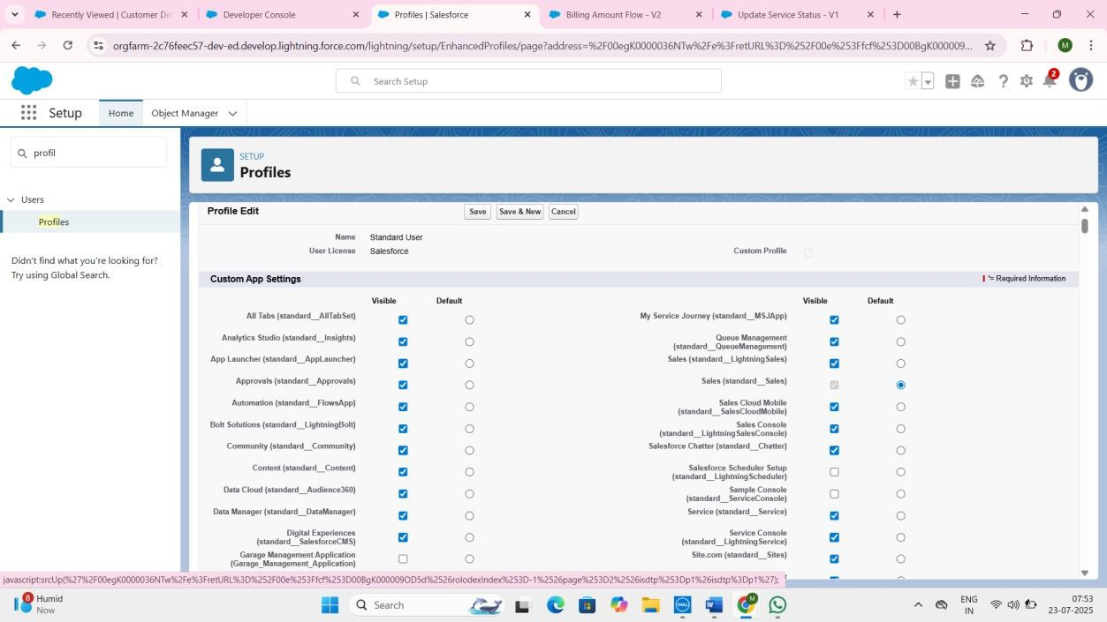

**Sales Person Profile:** (Detail permissions for this profile as well, likely Read/Create/Edit on relevant objects, possibly not Delete or View All/Modify All).

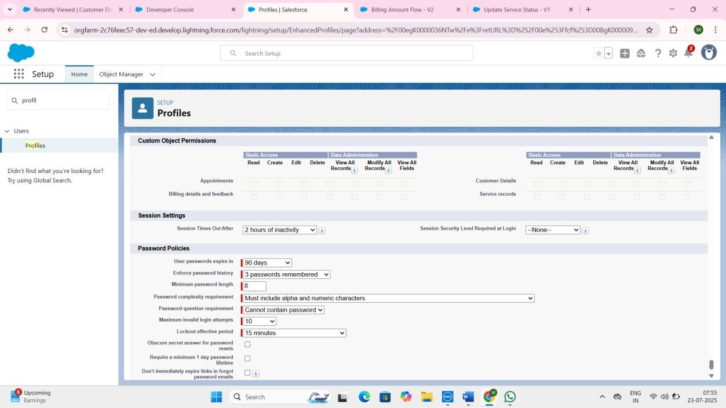

**Roles and Role Hierarchy:**

* **Hierarchy: *Sales Person*** roles report to the ***Manager*** role**.**
* **Purpose:** Defines data visibility based on organizational hierarchy; users can typically see data owned by users below them in the hierarchy.

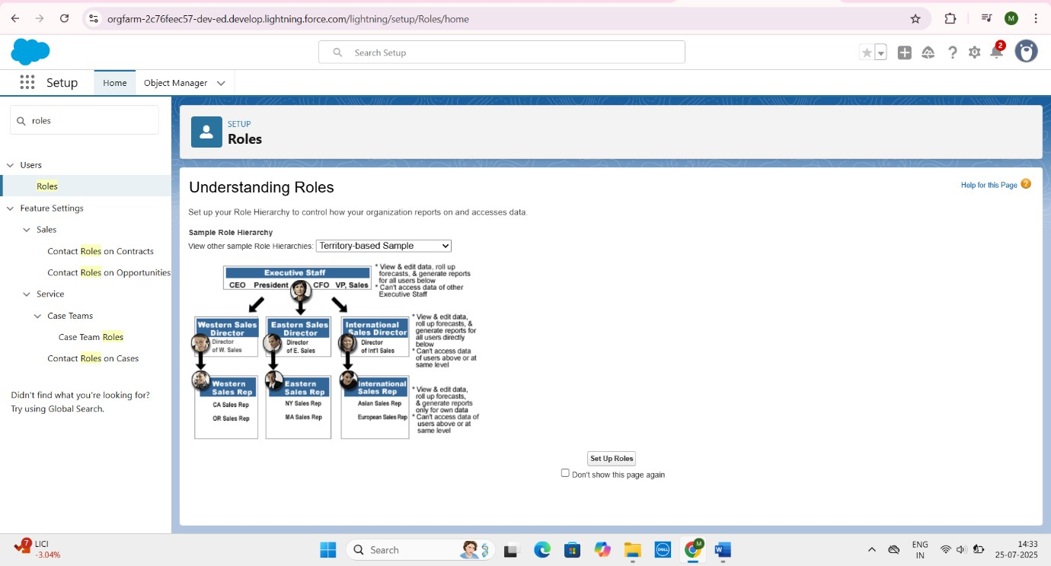

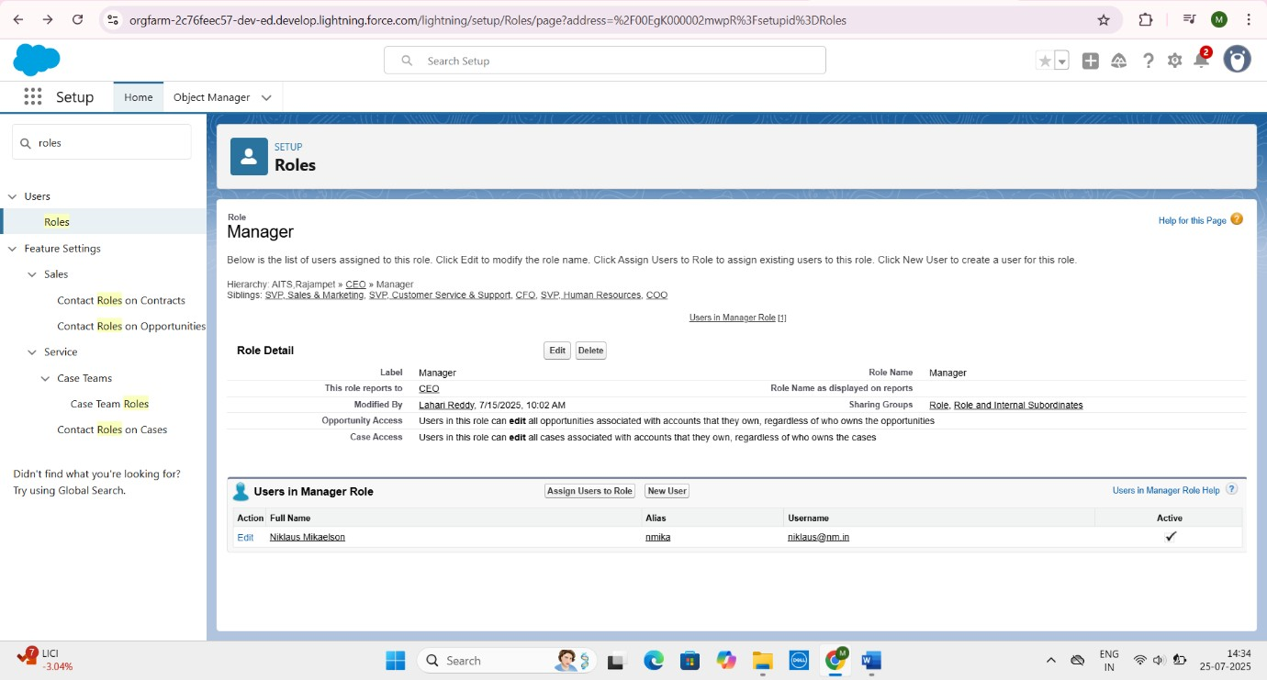

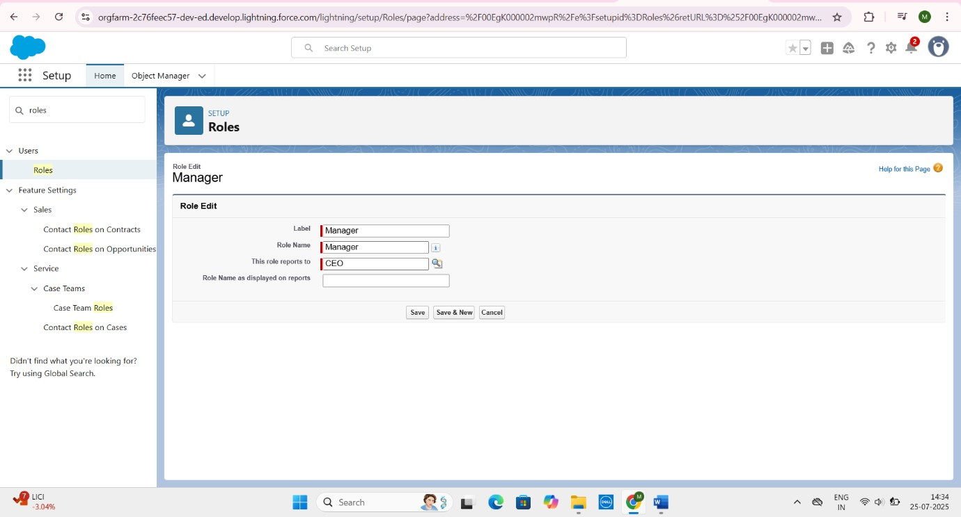

**Sharing Rules:**

* **Rule Name: Sharing setting** o **Object:** Service records
  + - **Purpose:** Explicitly shares Service records owned by users in the Sales Person role with users in the Manager role.
    - **Access Level:** Read/Write.
* 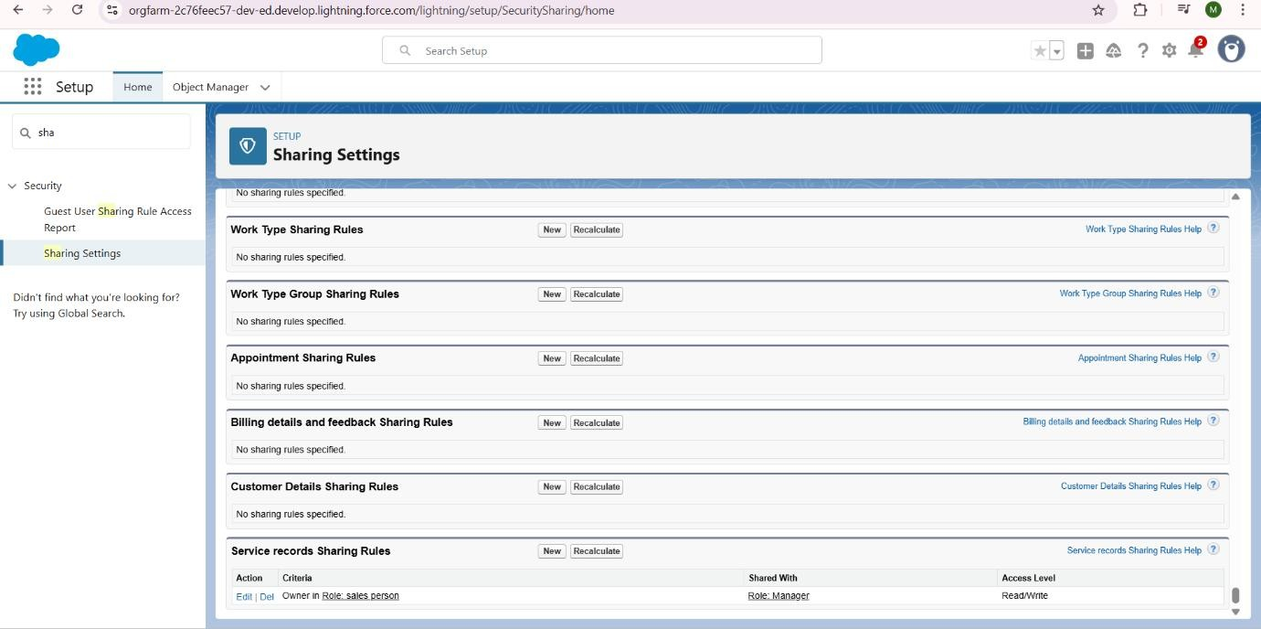

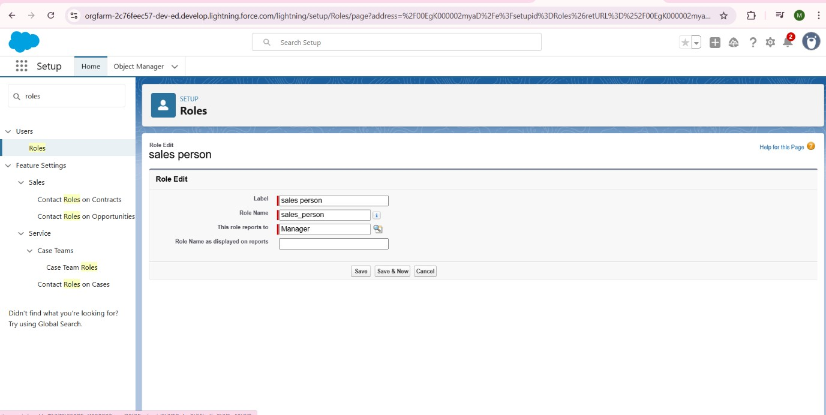



**6.4 Preparation of Test Cases:**

Detailed test cases were prepared and executed to validate the functionality of each Salesforce feature.

* **Test Case 1: Appointment Service Amount Automation** 
  + - **Feature: *Apex Trigger AmountDistribution*** and ***Handler AmountDistributionHandler***

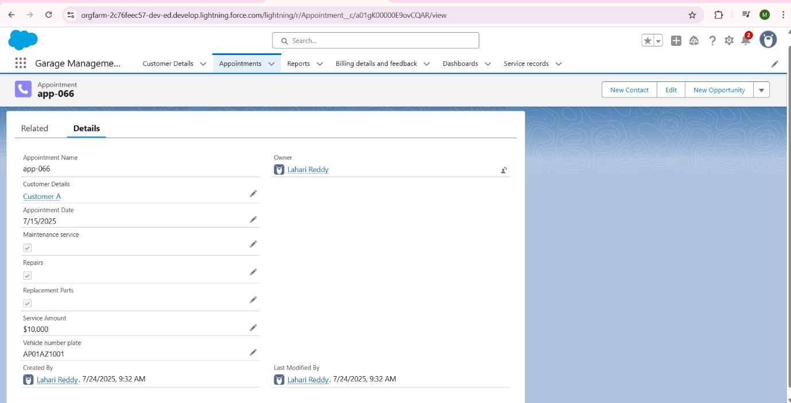

* + - **Input:** Create an Appointment record.
      * **Customer Details:** Link to Test Customer A
      * Appointment Date
      * Vehicle number plate
      * **Maintenance service:** Checked, Repairs: Checked, Replacement Parts: Checked

o **Expected Output:** Service Amount field automatically populated with 10000.

**Test Case 2: Vehicle Number Plate Validation**

* **Feature:** Validation Rule Vehicle on Appointment

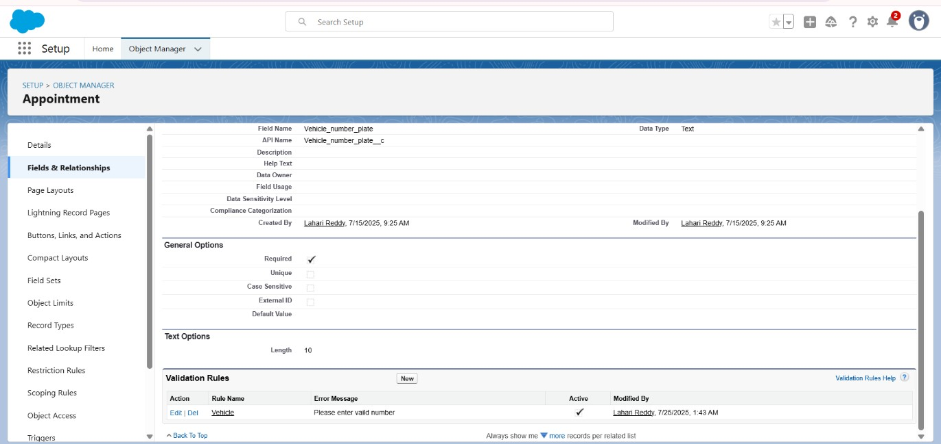

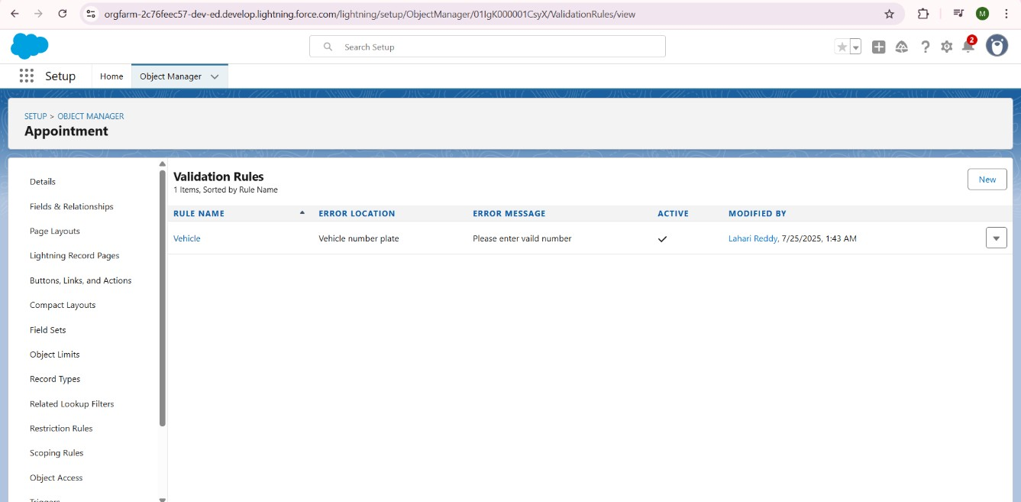

* **Input:** Attempt to create an Appointment record with invalid Vehicle number plate.

o Vehicle number plate

* **Expected Output:** Error message "Please enter valid number" displayed, record not saved.

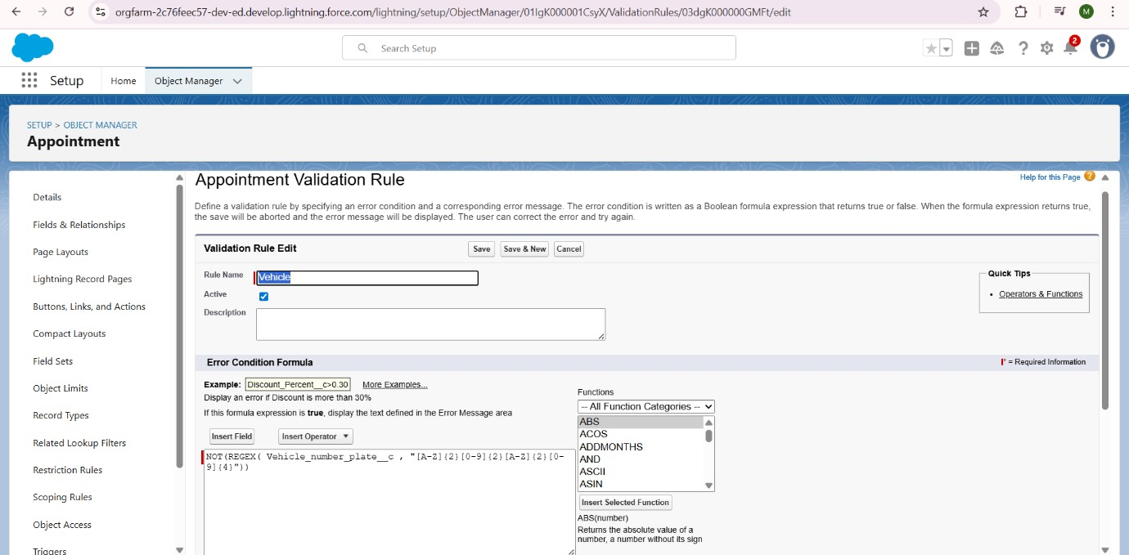

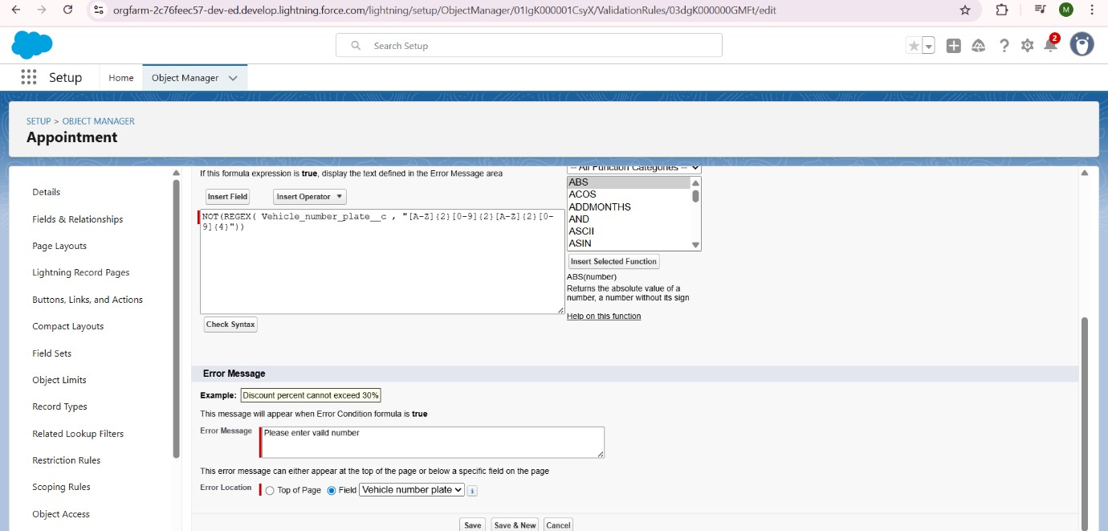

**Test Case 3: Service Status Automation**

* **Feature:** Flow ***Update Service Status***
* **Input:** Create a Service records record, link to a valid Appointment.

o **Initial Service Status: *Started***o Then, update the record and check ***Quality Check Status***.

* **Expected Output: *Service Status*** automatically updates to ***Completed*.**

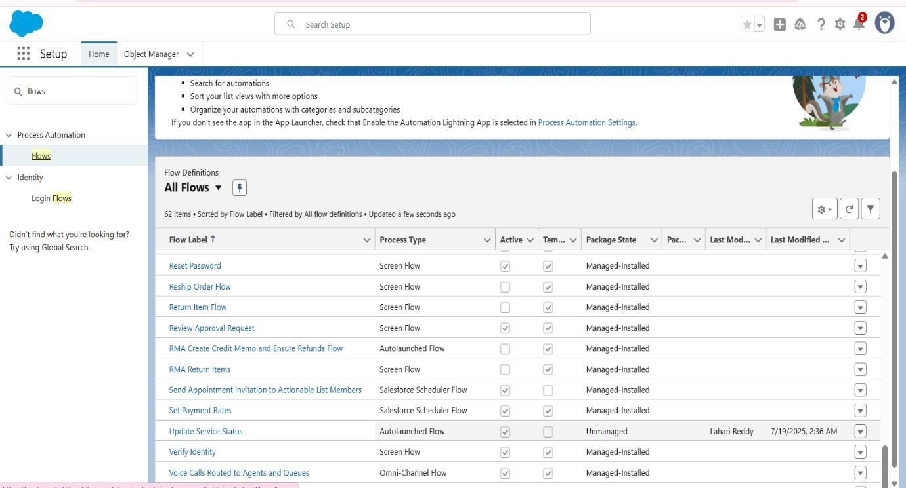

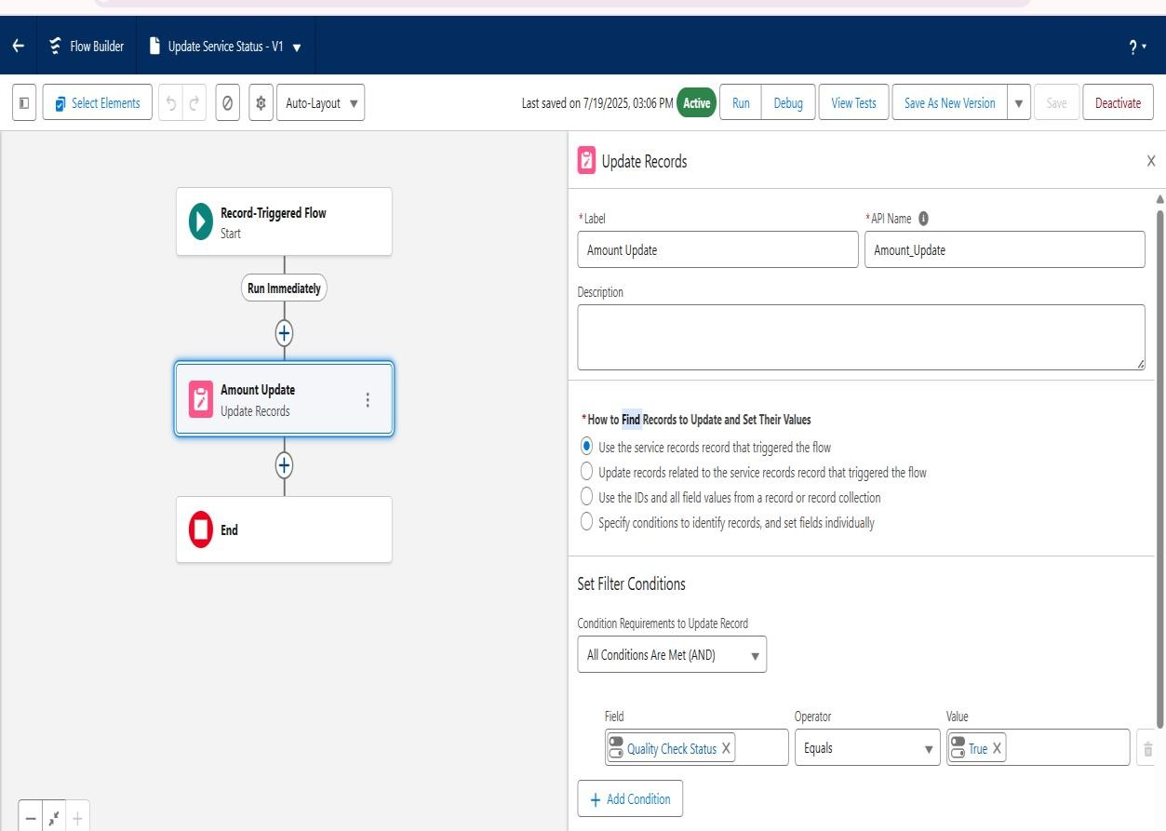

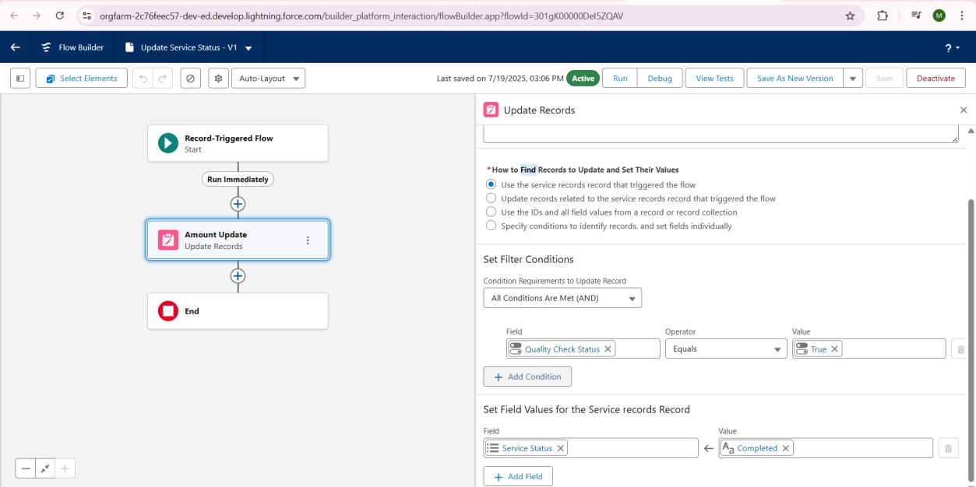

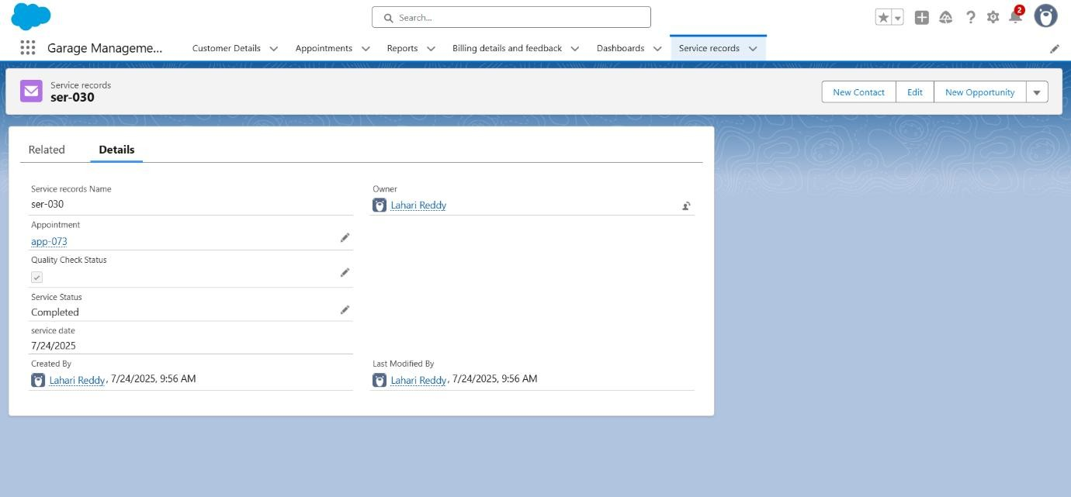

**Test Case 4: Billing Payment & Email Automation**

* **Feature:** Flow ***Billing Payment and Email Flow***
* **Input:** Create a ***Billing details and feedback*** record, link to a ***Service records*** record that's linked to an ***Appointment*** with a ***Service Amount*** and a ***Customer Details*** with a valid ***Gmail***. Then, update ***Payment Status*** to ***Completed***.
* **Expected Output:** 
  + 1. ***Payment Paid*** field automatically populated with ***Service Amount*** from Appointment.
    2. Thank you email sent to customer's Gmail.

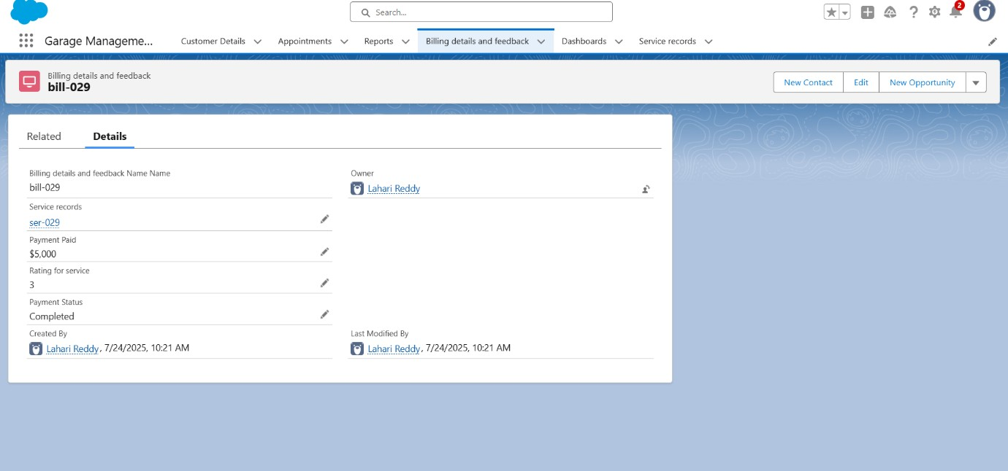

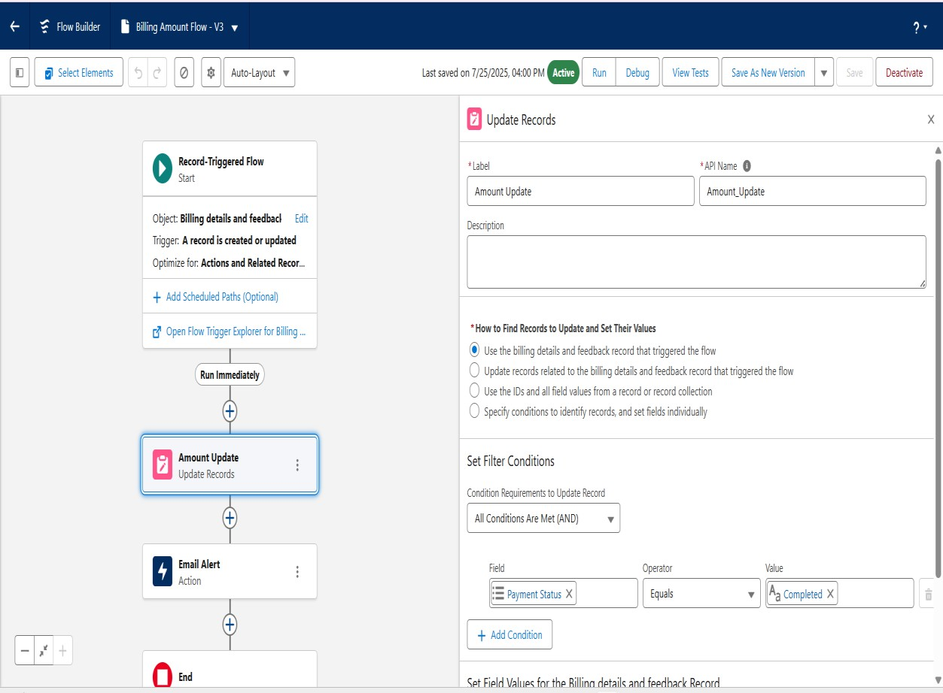

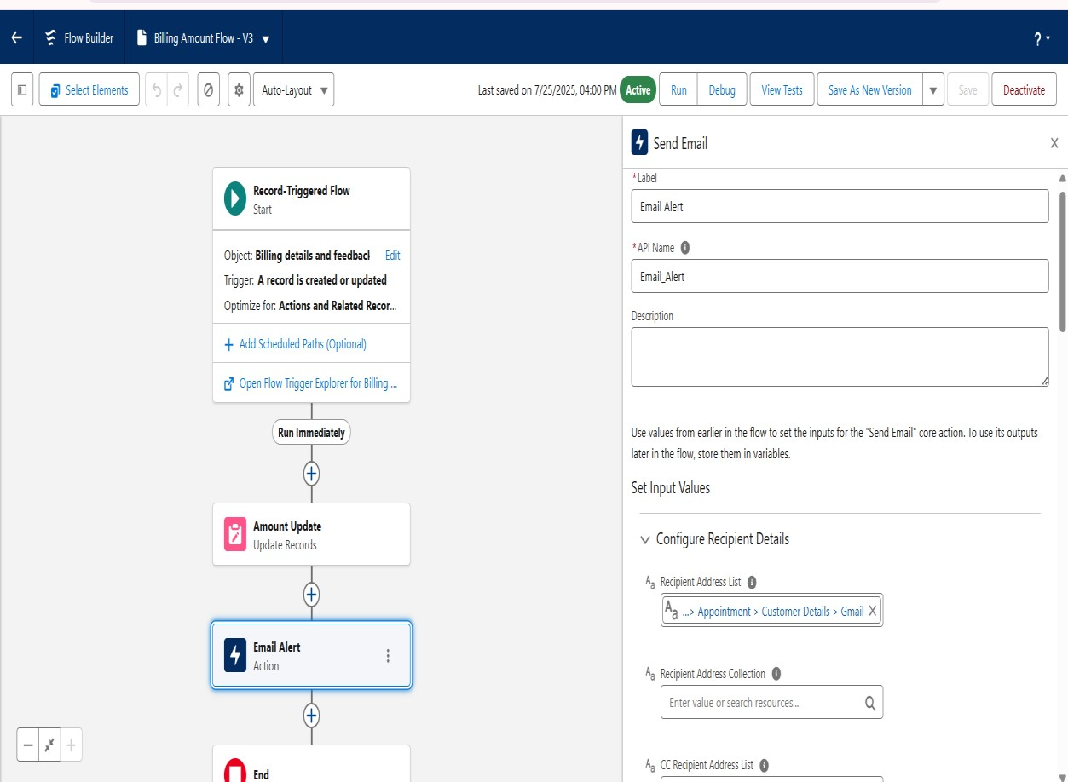

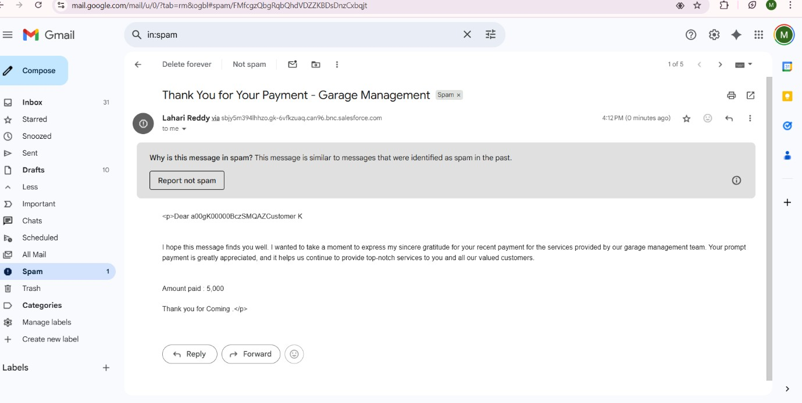

**Test Case 5: Service Records Sharing**

* **Feature:** OWD and Sharing Rule for Service records
* **Input:** 
  + 1. Log in as a Sales Person user and create a Service records record (User A owns).
    2. Log in as another Sales Person user (User B). Attempt to view User A's record.
    3. Log in as Manager user. Attempt to view and edit User A's record**.**
* **Expected Output:** 
  + 1. User B (Sales Person) cannot see User A's record.
    2. Manager user can see and edit User A's record.

1. **Phase 5: Deployment, Documentation & Maintenance** 
   1. **Deployment Strategy:**

The deployment strategy for this project involves using Salesforce Change Sets. All custom objects, fields, validation rules, flows, Apex classes, Apex triggers, reports, dashboards, roles, profiles, and sharing settings would be packaged into outbound change sets from the development environment (sandbox) and then deployed to a testing environment, and finally to the production environment.

* 1. **Basic Description of Maintenance and Monitoring:**

System maintenance will involve regular monitoring of Apex logs for errors, reviewing flow interview logs for automation issues, and tracking user adoption. Scheduled data clean-up (e.g., archiving old records) will be planned. Regular health checks will be performed to ensure optimal system performance.

* 1. **Documentation of Troubleshooting Approach:** 
     + **Flows:** Utilize Flow Debugger for step-by-step execution trace and error messages.
     + **Apex:** Monitor Apex Debug Logs in Developer Console to identify runtime errors and exceptions.
     + **Emails:** Verify email deliverability settings and check Salesforce Email Log Files for delivery status and error codes.
     + **Validation Rules:** Test by deliberately entering invalid data to confirm error messages.
     + **Sharing:** Use the "Sharing Reasons" and "View Sharing" buttons on records to understand data access.

1. **Conclusion**

The Garage Management System, built on Salesforce CRM, successfully addresses the core business requirements of automating and streamlining operations for an automotive service center. Through the implementation of custom objects, robust validation rules, powerful Flows, and Apex triggers, the system ensures data quality, automates critical workflows like service amount calculation and payment confirmation, and provides enhanced customer communication. The security model, including OWD, roles, profiles, and sharing rules, ensures appropriate data access. Comprehensive reports and dashboards offer valuable business insights. The project was thoroughly tested to confirm the functionality of all implemented features, laying a strong foundation for efficient garage operations.